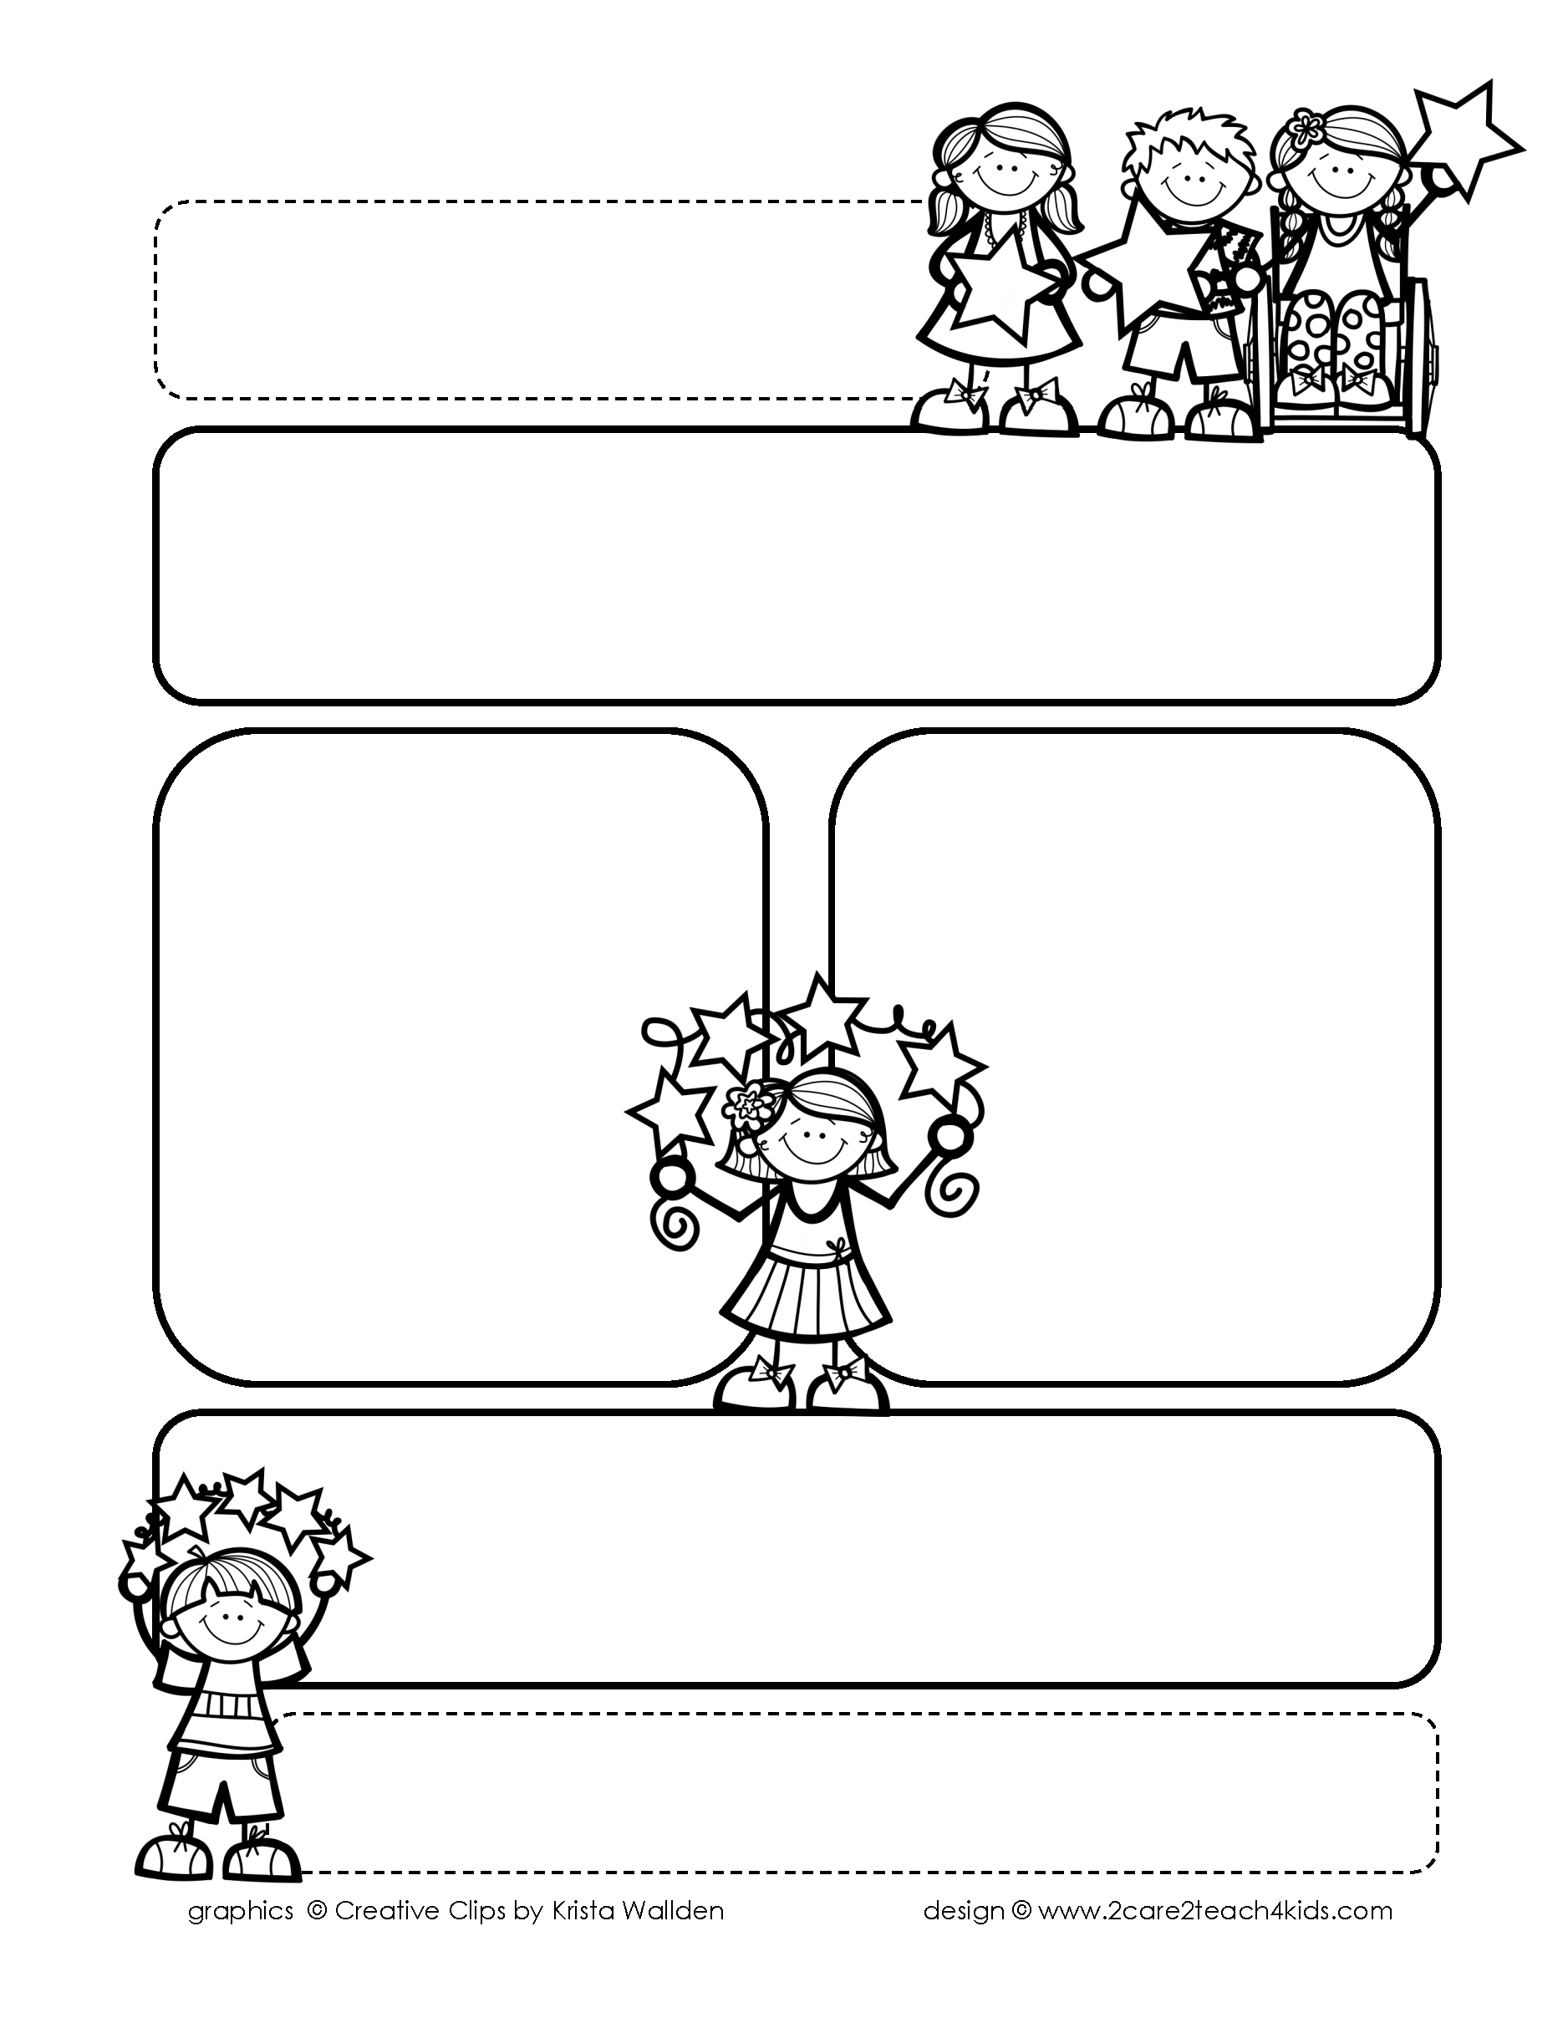

Peek of the Week-First Grade

April 11-14, 2022

, 2021

**Reading/Phonics/Writing**

Students will work on identifying the Author’s Purpose in “Henry & Mudge & Mrs. Hopper’s House”-Reading Street, Making Predictions, Punctuation, Suffixes, Adjectives, Writing Poetry, Comprehension, read and spell words with /kn, gn/.

.

**Math/Science/Social Studies:**

Students will learn about counting Money .

Students will learn about the Life Cycle of a Chick.

Students will continue Past and Present and continue American Inventors.

Word problems

**Religion:**

Students will learn about the meaning of Easter.

.

!

**Reminders:**

* **Send egg carton and 12 plastic (empty) eggs by Tuesday.**
* **Early Release on Thursday.**
* **Our last Rosary will be at 7:30 Wednesday! You may bring a Rosary.**

.

**No**

**Spelling**