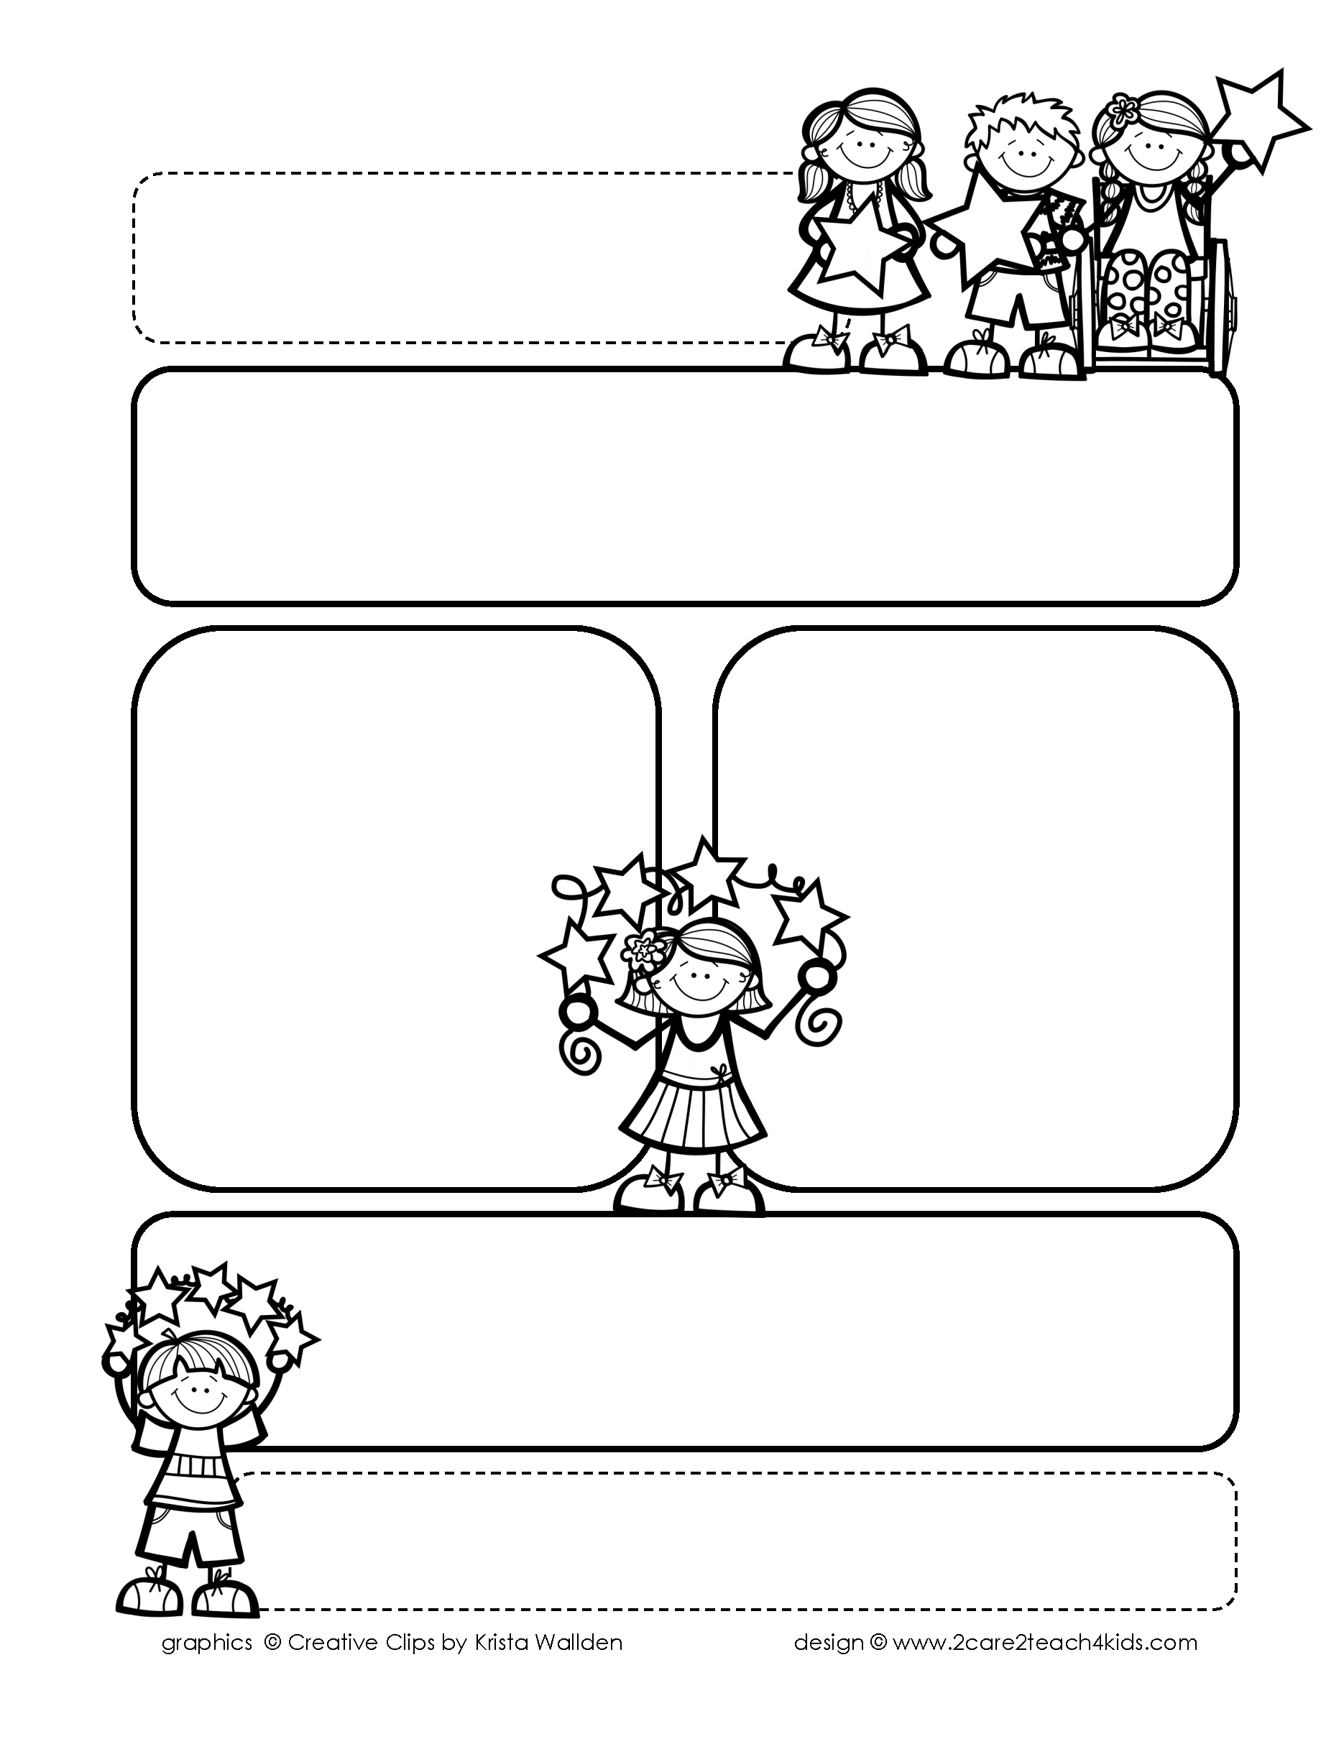

Peek of the Week-First Grade

April 18-22, 2022

, 2021

**Reading/Phonics/Writing**

Students will work on identifying the Author’s Purpose in “Tippy -Toe Chick Go!”-Reading Street, Making Predictions, Commands, Suffixes, Adjectives, Writing Poetry, Comprehension, read and spell words with /wr/.

.

**Math/Science/Social Studies:**

Students will continue counting Money .

Students will learn about Insects and Earth Day.

Students will continue Past and Present and continue American Inventors.

Word problems

**Religion:**

Students will learn the Importance of Prayer.

.

!

**Reminders:**

* **Send a self-addressed envelope to someone special to your child. Due Tuesday, 4/19**
* **Remember to buy your Gala ticket! Can’t wait to see you on 4/23!**
* **Field Day: 4/29 Pomes’ Class:Wear Red T-Shirt**

**Van Essen’s Class: Wear Yellow t-shirt**

.

**Spelling**

**NO PRE-TEST**

**THIS WEEK!**

**We will take a test on**

**Random Words from**

**List 21-25.**

**Please study words from**

**The A and “Both” sections**

**Of the cards. This is to see if your child is applying the phonics that has been taught through the spelling words.**