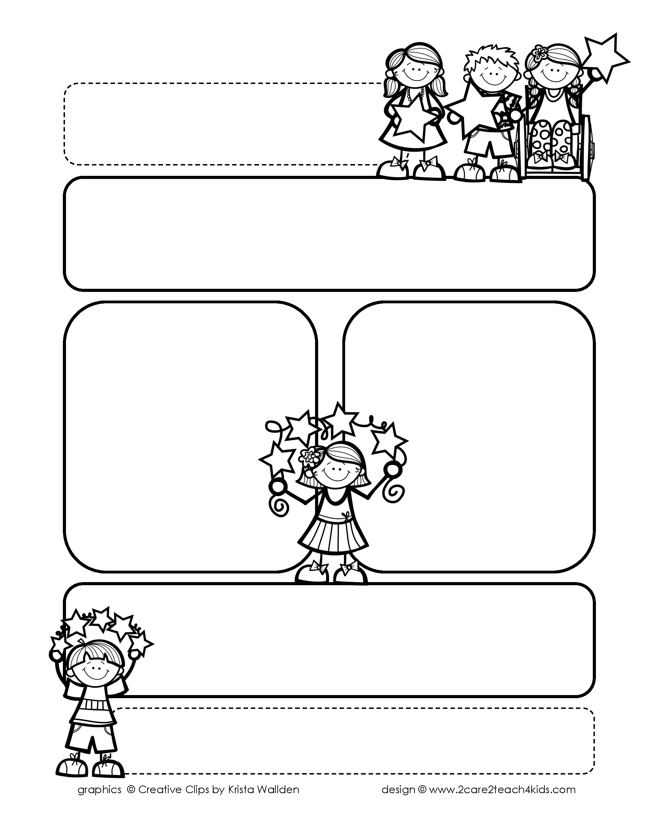

Peek of the Week-First Grade

April 25-29, 2022

, 2021

**Reading/Phonics/Writing**

Students will work on identifying the Author’s Purpose in “Mole & Baby Bird”-Reading Street, Making Predictions, Exclamations, Suffixes, Writing Poetry, Comprehension, and Ending Blends.

.

**Math/Science/Social Studies:**

Students will learn about 2D shapes & Equal Shares.

Students will continue to learn about Insects.

Students will learn about Traditions We Share.

Word problems

**Religion:**

Students will learn the Importance of Prayer and The Story about Fishers of Men .

.

!

**Reminders:**

* **Social Studies Test Tuesday over Chp.5 Past and Present**
* **5/2 NWEA Reading Benchmark**

**5/3 NWEA Math Benchmark**

* **Field Day: 4/29 Pomes’ Class:Wear Red T-Shirt**

**Van Essen’s Class: Wear Yellow t-shirt**

* **Mom’s Tea 5/4 @ 1:45;**

**Students wear Sunday’s best!**

.

**No Spelling**