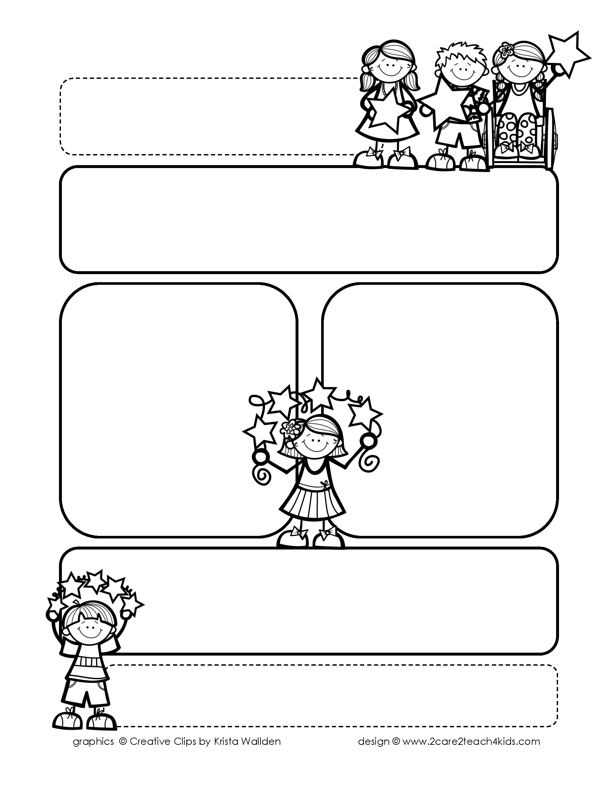

Peek of the Week-First Grade

April 4-8, 2022

, 2021

**Reading/Phonics/Writing**

Students will work on identifying the Author’s Purpose in “Peter’s Chair”-Reading Street, Making Predictions, Punctuation, Homophones, Adjectives, Abbreviations, Writing Poetry, Comprehension, read and spell words with /dge/.

.

**Math/Science/Social Studies:**

Students will learn begin Chp. 9 on Money .

Students will learn about the Life Cycle of a Frog.

Students will continue Past and Present and continue American Inventors.

Word problems

**Religion:**

Students will learn about how We Care for the Gifts of God’s Creation.

.

!

**Reminders:**

* **Wed., 4/6 Chp. 8 Math Test on Measurement & Time**
* **Tues., 4/5 Chp. 8 Science Test on The Sky**
* **Fri., 4/8 Chp.5 Social Studies**

**Test**

* **NWEA Rdg. Fluency Benchmark: Van Essen-4/6**
* **On Wednesdays try to be here by 7:30 for a decade of the**

**Rosary. You may bring a**

**Rosary.**

.

**Spelling Words**

* Pre-Test will be given on Monday to determine if your list will be A or B.
* Study list (A or B) and the “Both” words on the spelling

word card. Please keep the Spelling Ring in the pouch that is in Daily folder. A new card will come home every Monday. Also, study the spelling of the sight words on the back of the card.