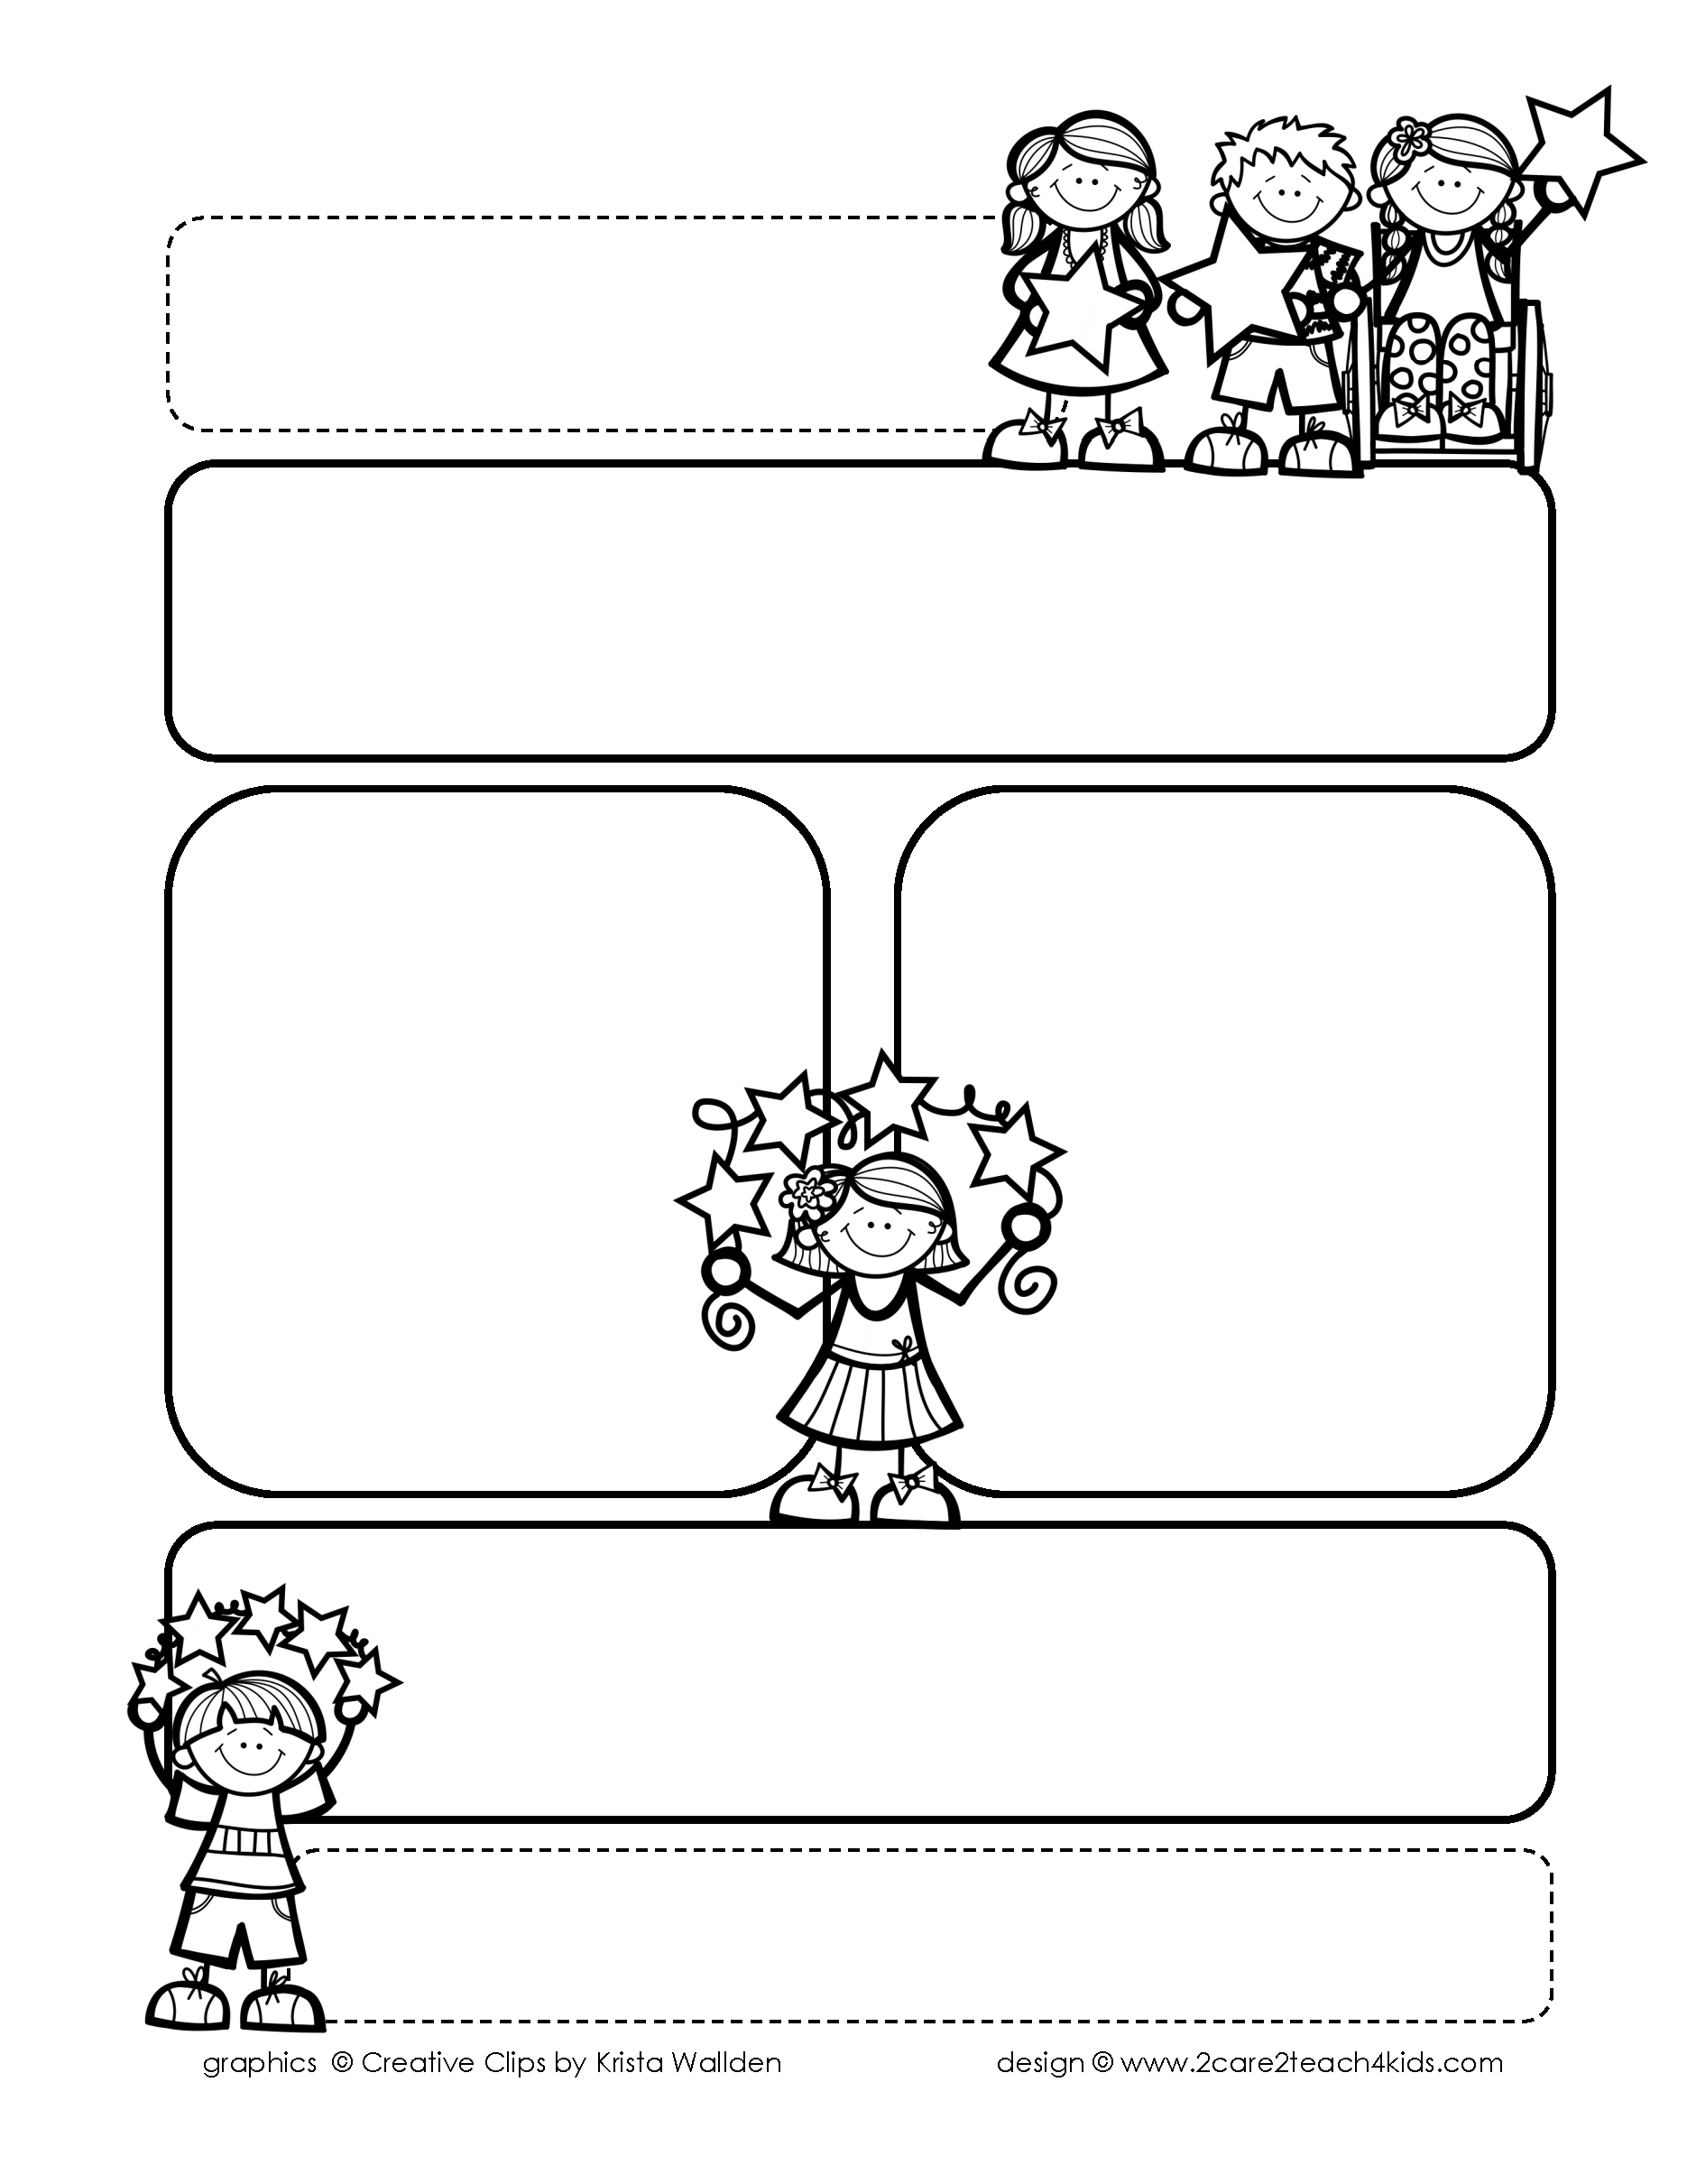

Peek of the Week-First Grade

February 14-18, 2022

, 2021

**Reading/Phonics/Writing**

Students will work on identifying the Author’s Purpose, Fact & Opinion, Drawing Conclusions, Common/Proper Nouns, Punctuation, Comprehension, read and spell words with /oo/, /au/,/aw/.

.

**Math/Science/Social Studies:**

Students will complete Chp.6 Adding & Subtracting 10’s.

Students will complete learning about the Earth’s Resources.

Students will learn about African-American Inventors.

Word problems

**Religion:**

Students will learn about St. Valentine.

!

**Reminders:**

* **Monday, Valentine Party! Bring Valentine Cards.**
* Math Test is on **Wednesday.**
* Science Test is on **Friday.**
* Homework is due **Friday**! (that includes Math, Reading Fluency & Spelling Homework.)
* No School Feb.21st-Teacher Inservice

.

**Spelling Words**

* Pre-Test will be given on Monday to determine if your list will be A or B.
* Study list (A or B) and the “Both” words on the spelling

word card. Please keep the Spelling Ring in the pouch that is in Daily folder. A new card will come home every Monday. Also, study the spelling of the sight words on the back of the card.