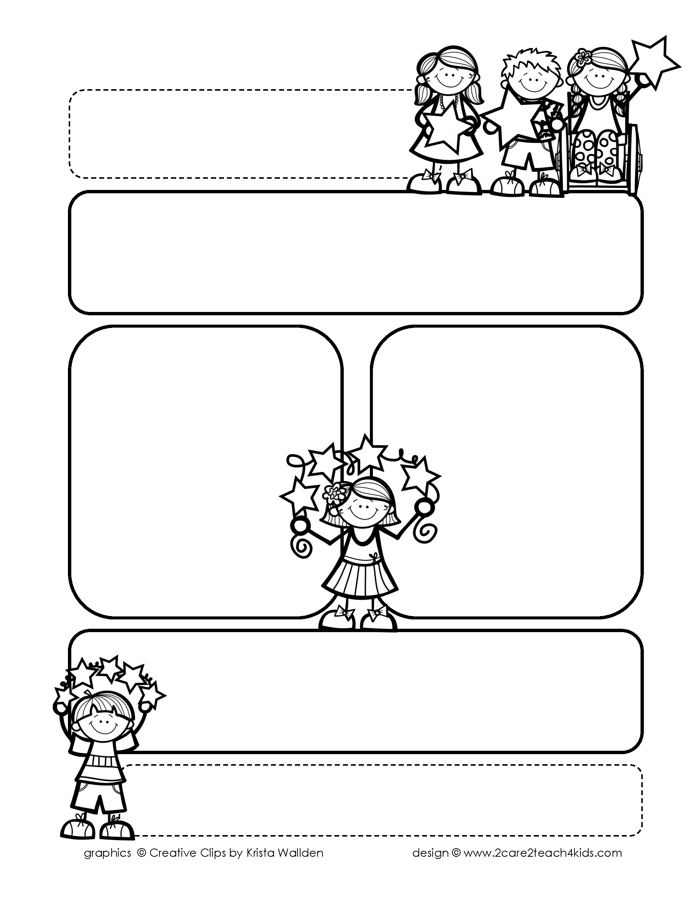

Peek of the Week-First Grade

February 21-25, 2022

, 2021

**Reading/Phonics/Writing**

Students will work on identifying the Author’s Purpose, Fact & Opinion, Drawing Conclusions, Letter Writing, Punctuation, Suffixes, Fairy Tales, and Comprehension.

.

**Math/Science/Social Studies:**

Students will learn about Organizing & Using Graphs.

Students will complete learning about Weather & Seasons.

Students will learn about The Presidents.

Word problems

**Religion:**

Students will learn that Jesus Give Us the Eucharist.

!

**Reminders:**

* **Monday, Feb.21st Teacher Inservice-No School**
* **Library is on Tuesday this week!**
* 2-22-22 **Two’s Day-Wear Ties & Tutu’s. Please send an**

**empty Toilet or Paper towel roll.**

* **Your child may bring an offering to mass for the collection basket. Please have it in an envelope.**
* Homework is due **Friday**! (that includes Math, Reading Fluency & Spelling Homework.)

.

**Spelling**

**NO PRE-TEST**

**THIS WEEK!**

**We will take a test on**

**Random Words from**

**List 14-20.**

**Please study words from**

**The A and “Both” sections**

**Of the cards. This is to see if your child is applying the phonics that has been taught through the spelling words.**