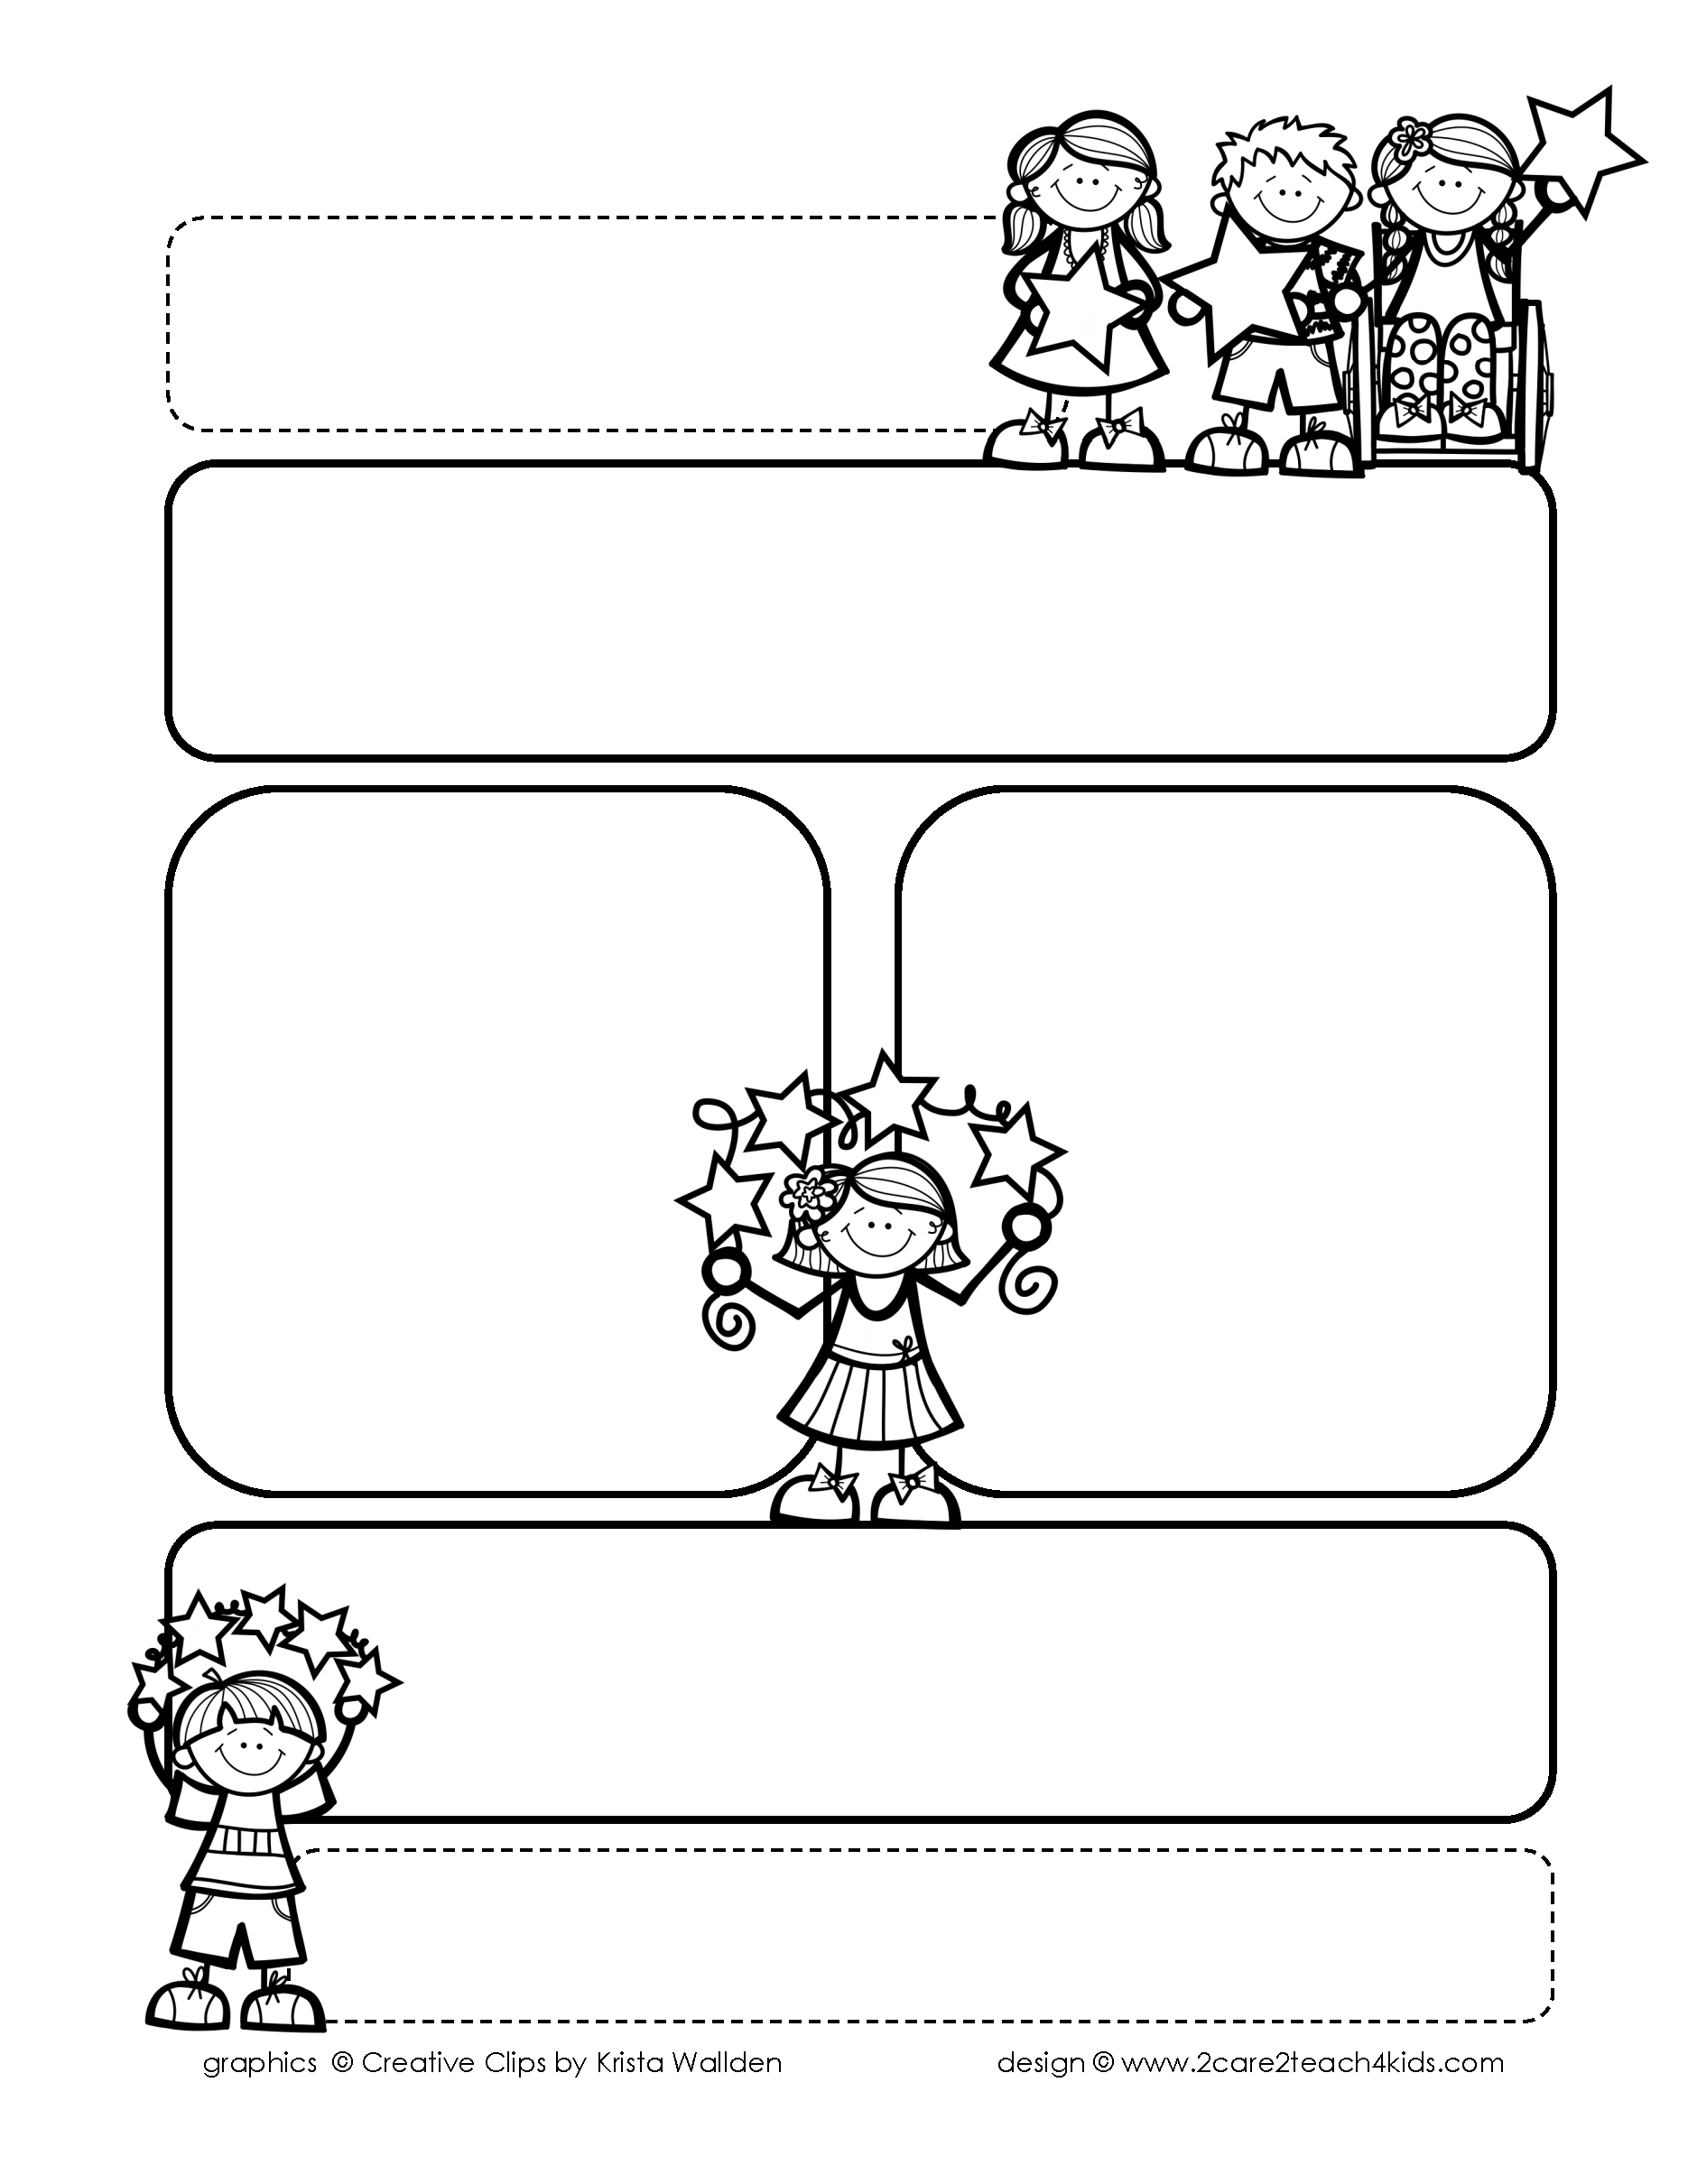

Peek of the Week-First Grade

February 28-March 4, 2022

, 2021

**Reading/Phonics/Writing**

Students will work on identifying the Author’s Purpose, Nouns, Verbs, Punctuation, Contractions, Comprehension, read and spell words with /ed/.

.

**Math/Science/Social Studies:**

Students will continue learning about Organizing & Reading Graphs.

Students will complete learning about the Water Cycle.

Students will learn about Mardi Gras and the Presidents.

Word problems

**Religion:**

Students will learn about Lent & Ash Wednesday.

!

**Reminders:**

* **Tuesday is Mardi Gras-wear purple, green,& gold with jeans.**
* **Ash** **Wednesday is March 2-Wear Mass uniform.**
* **Thursday, March 3-Dr. Suess**

**Day-You may wear Dr. Suess attire. Bring blanket for Read**

**In.**

* **Friday, March 4-Go Texan Day-Dress in Western attire.**

.

**Spelling Words**

* Pre-Test will be given on Monday to determine if your list will be A or B.
* Study list (A or B) and the “Both” words on the spelling

word card. Please keep the Spelling Ring in the pouch that is in Daily folder. A new card will come home every Monday. Also, study the spelling of the sight words on the back of the card.