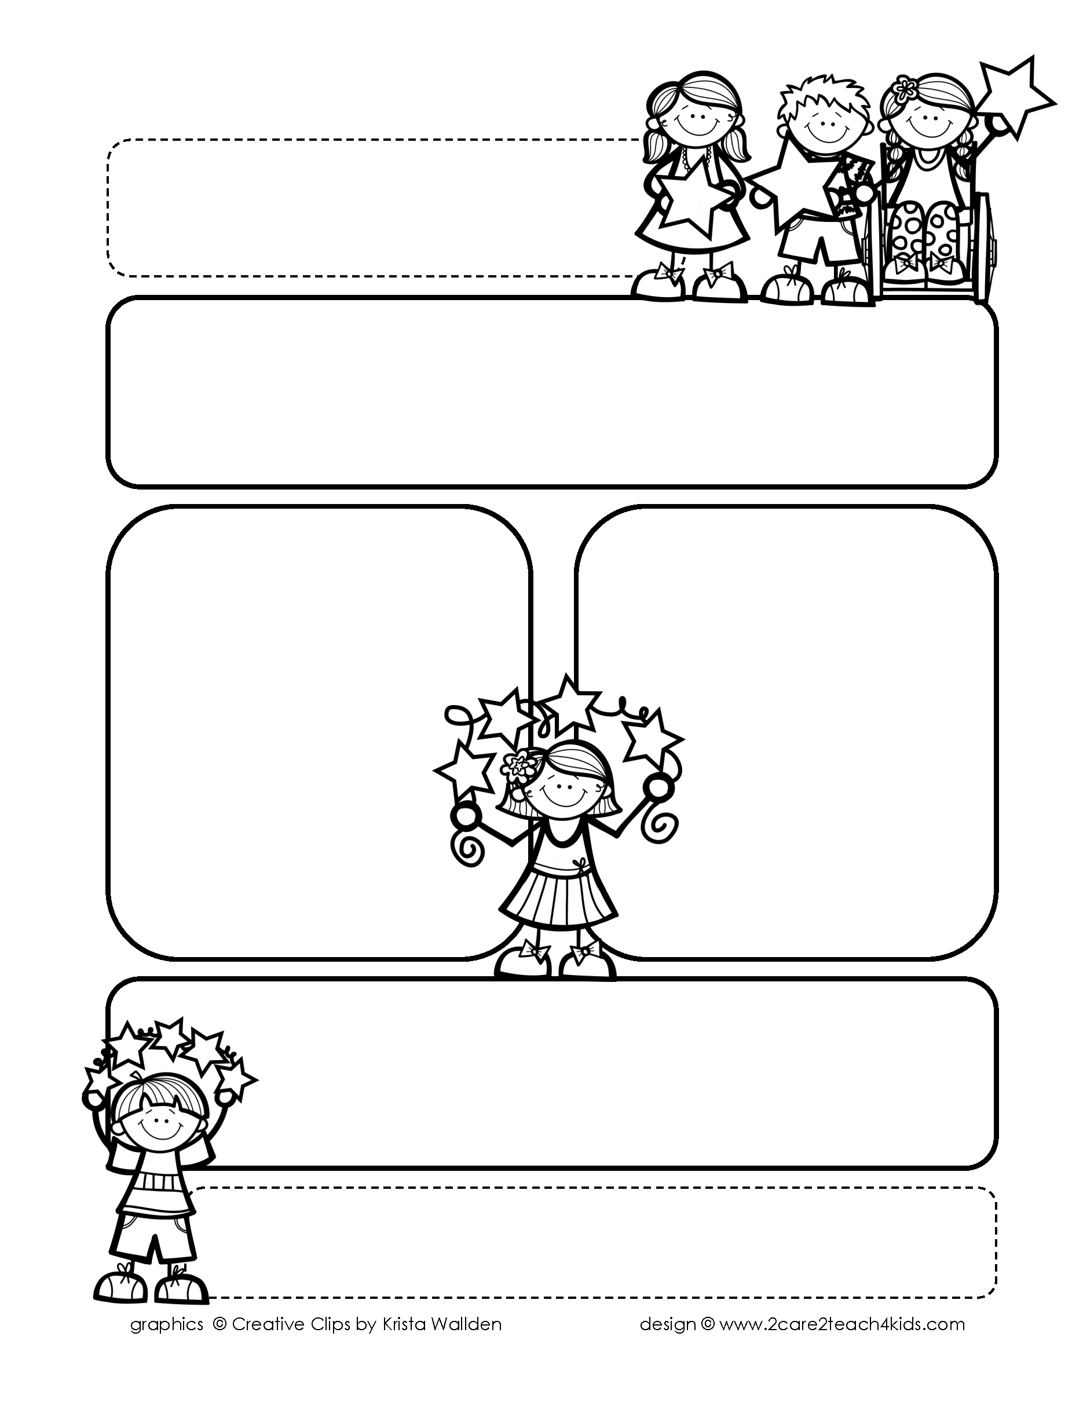

Peek of the Week-First Grade

February 7-11, 2022

, 2021

**Reading/Phonics/Writing**

Students will work on identifying the Author’s Purpose, Fact & Opinion, Making Predictions, Drawing Conclusions, Possessive Nouns, Comprehension, read and spell words with /ou/,/ow,//ew/.

.

**Math/Science/Social Studies:**

Students will learn Adding & Subtracting by 10’s.

Students will learn about the Earth’s Resources.

Students will complete Chp.3 on Looking at our World.

Word problems

**Religion:**

Students will learn about Lent.

!

**Reminders:**

* Homework is due **Friday**! (that includes Math, Reading Fluency & Spelling Homework.
* Social Studies Test is on **Friday.**
* When your child brings a book to test on AR it must be on their

reading level.

**Spelling Words**

* Pre-Test will be given on Monday to determine if your list will be A or B.
* Study list (A or B) and the “Both” words on the spelling

word card. Please keep the Spelling Ring in the pouch that is in Daily folder. A new card will come home every Monday. Also, study the spelling of the sight words on the back of the card.