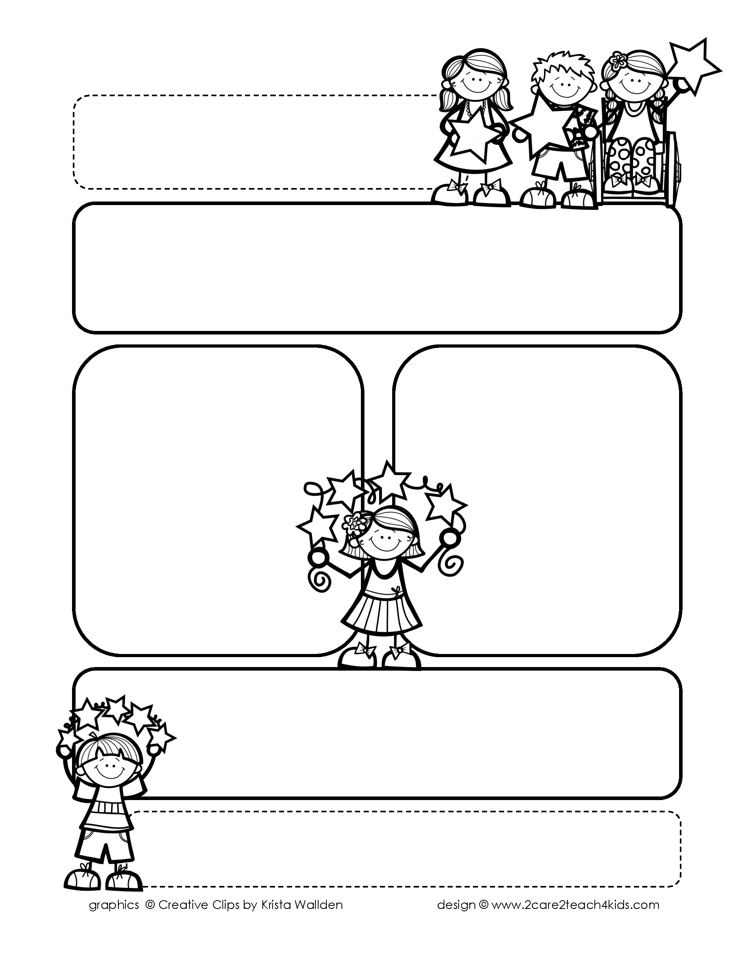

Peek of the Week-First Grade

January 10-14, 2022

, 2021

**Reading/Phonics/Writing**

Students will work on identifying Text Features of Non-Fiction (Informational Text), Author’s Purpose, Compound Words, Adjectives, Comprehension and

Writing Complete Sentences.

.

**Math/Science/Social Studies:**

Students will learn about Greater Than, Less Than and Equal.

Students will learn about Directions on a Map and Martin Luther King.

Students will learn about Rocks and Soil.

Word problems

**Religion:**

Students will learn that We Celebrate Sacraments.

!

**Reminders:**

* It is cold in our classroom. So please send a sweater or jacket with your child.
* Homework is due **Friday**! (that includes Math, Reading Fluency & Spelling Homework)
* Mass on **Friday!**

**Spelling Words**

* Pre-Test will be given on Monday to determine if your list will be A or B.
* Study list (A or B) and the “Both” words on the spelling

word card. Please keep the Spelling Ring in the pouch that is in Daily folder. A new card will come home every Monday. Also, study the spelling of the sight words on the back of the card.