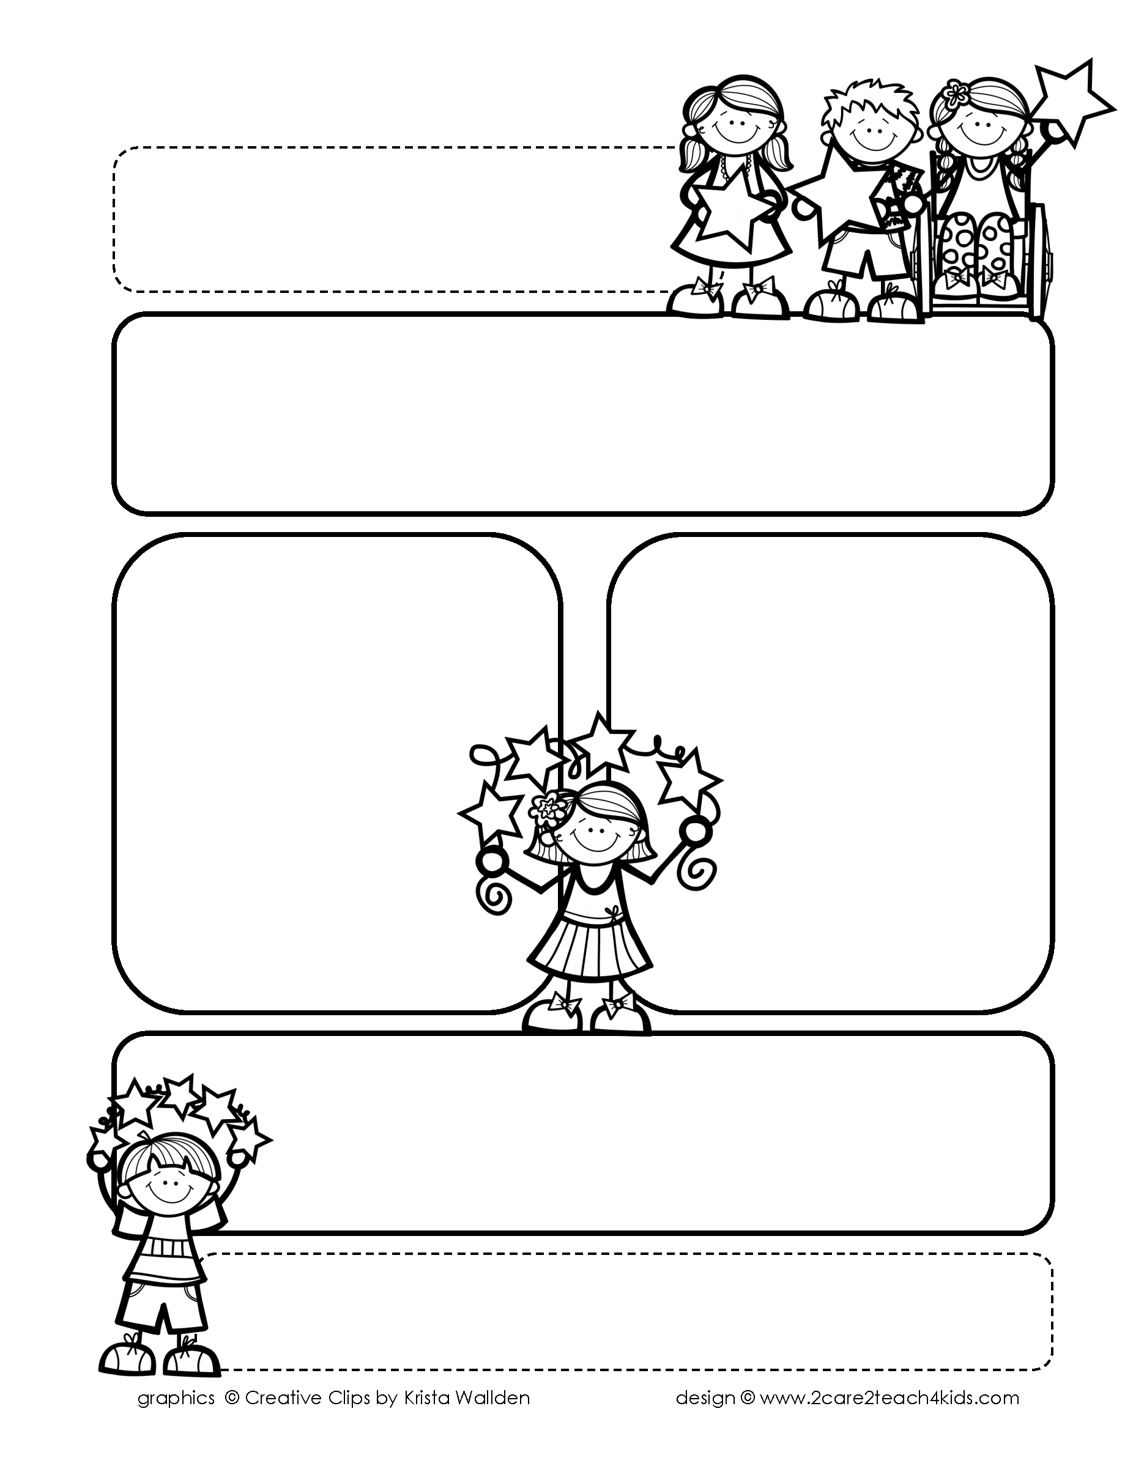

Peek of the Week-First Grade

January 17-21, 2022

, 2021

**Reading/Phonics/Writing**

Students will work on identifying Text Features of Non-Fiction (Informational Text), Author’s Purpose, Adjectives, Comprehension, Story Elements and

Writing Complete Sentences with Correct Punctuation.

.

**Math/Science/Social Studies:**

Students will learn about Greater Than, Less Than and Equal.

Students will continue learning about Martin Luther King and Fire Safety.

Students will continue learning about Earth Science.

Word problems

**Religion:**

Students will learn that The Church Welcomes New Members.

!

**Reminders:**

* No School Monday, Jan. 17th.
* Tues., Jan. 18th: Pearland Fire Dept. & EMS visit our school.
* It is cold in our classroom. So please send a sweater or jacket with your child.
* Homework is due **Friday**! (that includes Math, Reading Fluency & Spelling Homework!
* Math Test **Friday** on Chp.5
* Mass on **Friday!**

**Spelling Words**

* Pre-Test will be given on Tuesday to determine if your list will be A or B.
* Study list (A or B) and the “Both” words on the spelling

word card. Please keep the Spelling Ring in the pouch that is in Daily folder. A new card will come home every Monday. Also, study the spelling of the sight words on the back of the card.