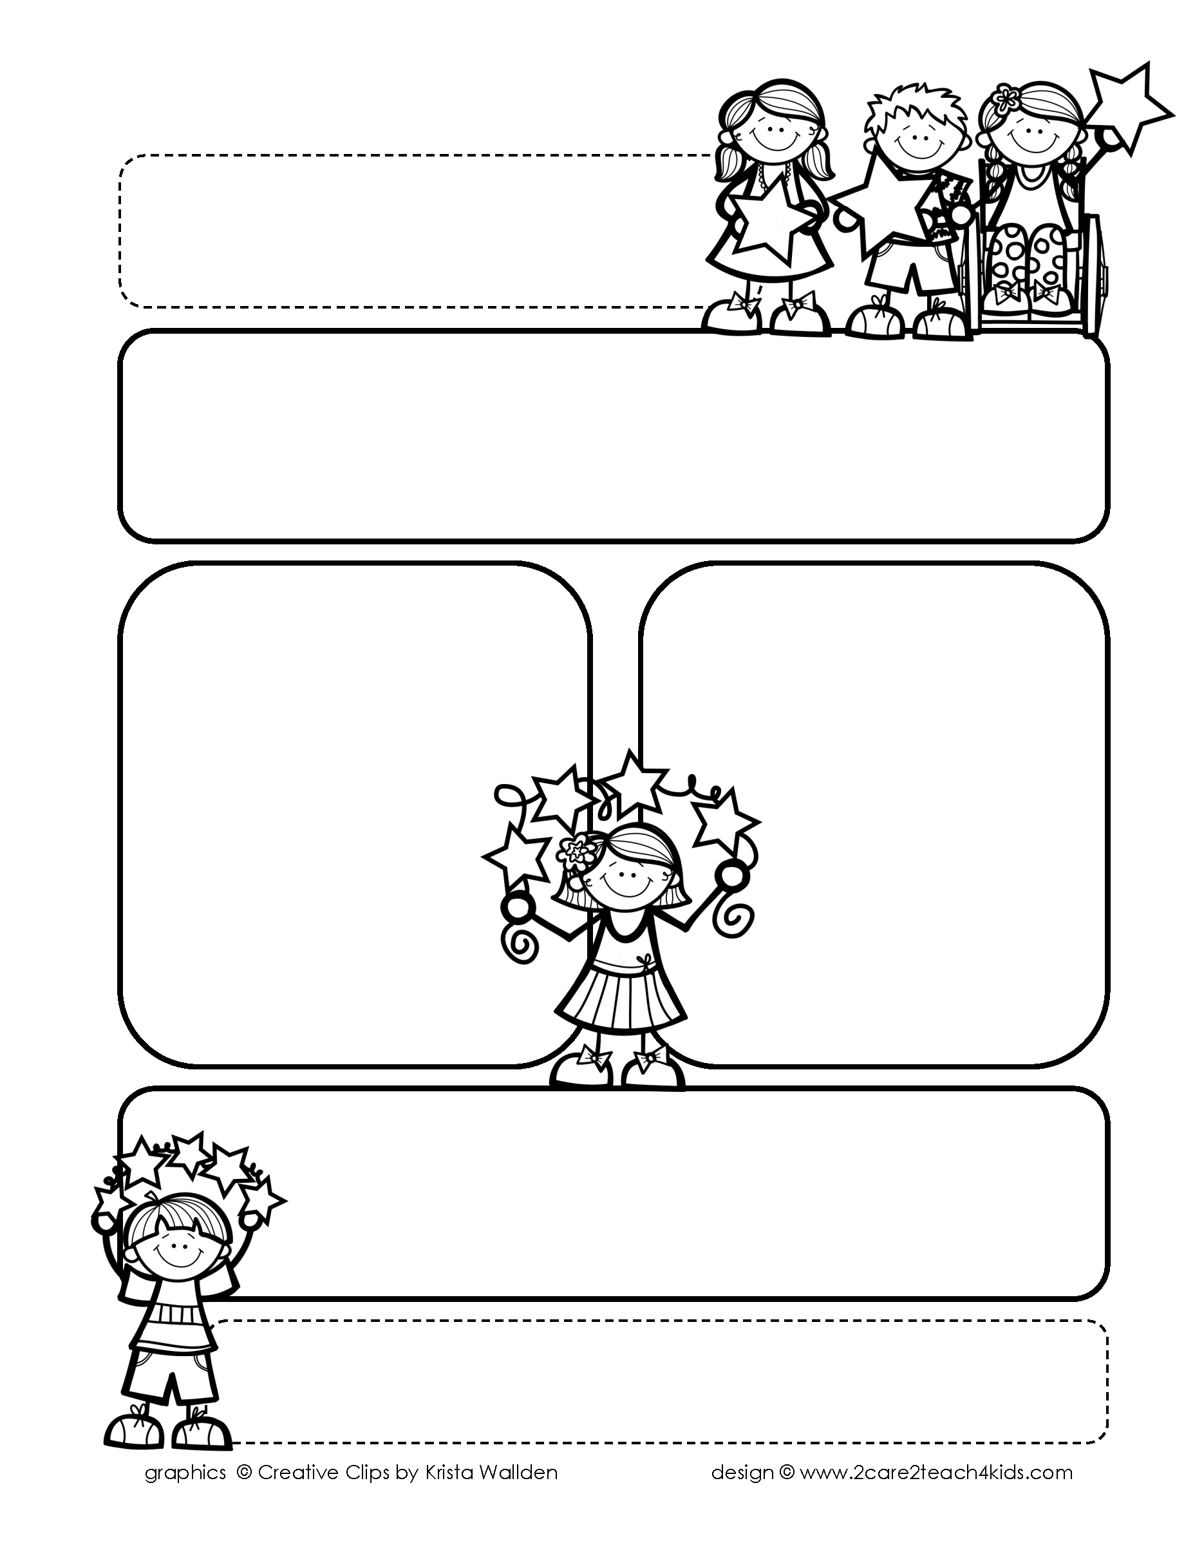

Peek of the Week-First Grade

January 24-28, 2022

, 2021

**Reading/Phonics/Writing**

Students will work on identifying Author’s Purpose, Making Predictions, Adverbs, Inflectional Endings, Comprehension, read and spell words with /ar,//or/and learn sound for /aw/, /au.

.

**Math/Science/Social Studies:**

Students will learn 2 Digit Addition and Subtraction.

Students will continue learning about Maps and Globes.

Students will complete our Earth Science Unit.

Word problems

**Religion:**

Students will learn that We Are Followers of Jesus.

!

**Reminders:**

* **Thurs., Jan. 27th Celebrate the 101 Day of School! Wear your white t-shirt with 101 black spots. Jeans are approved!**
* Wed., Jan.26th Science Test
* It is cold in our classroom. So please send a sweater or jacket with your child.
* Homework is due **Friday**! (that includes Math, Reading Fluency & Spelling Homework.
* Mass on **Friday!**

**Spelling Words**

* Pre-Test will be given on Monday to determine if your list will be A or B.
* Study list (A or B) and the “Both” words on the spelling

word card. Please keep the Spelling Ring in the pouch that is in Daily folder. A new card will come home every Monday. Also, study the spelling of the sight words on the back of the card.