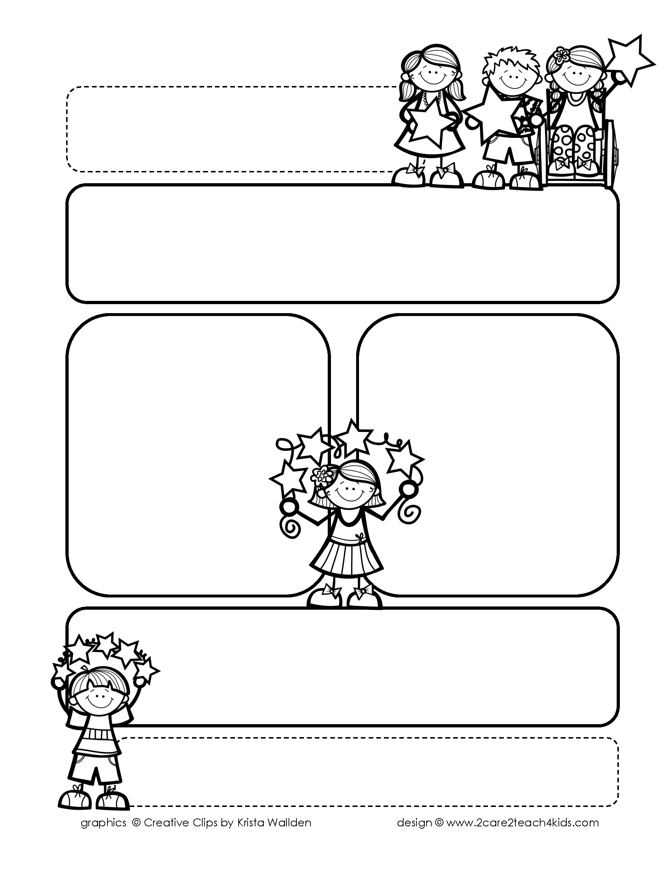

Peek of the Week-First Grade

March 28-April 1, 2022

, 2021

**Reading/Phonics/Writing**

Students will work on identifying the Author’s Purpose in “A Trip to Washington D.C.”-Reading Street, Punctuation, Adjectives, Abbreviations, Comprehension, read and spell words with /ed/ & /ing/.

.

**Math/Science/Social Studies:**

Students will learn about Time to the Hour & Half Hour.

Students will learn about the Moon Phases and the Planets.

Students will continue Past and Present and begin American Inventors.

Word problems

**Religion:**

Students will learn about how We Honor Mary and the Saints.

!

**Reminders:**

* **Remember to send a water bottle with your child.**
* **NWEA Rdg. Fluency Benchmark: Pomes-3/30, Van Essen-4/6**
* **On Wednesdays try to be here by 7:30 for a decade of the**

**Rosary. You may bring a**

**Rosary.**

* **Remember your child may**

**bring an offering for the collection basket on Mass Day.**

.

**Spelling Words**

* Pre-Test will be given on Monday to determine if your list will be A or B.
* Study list (A or B) and the “Both” words on the spelling

word card. Please keep the Spelling Ring in the pouch that is in Daily folder. A new card will come home every Monday. Also, study the spelling of the sight words on the back of the card.