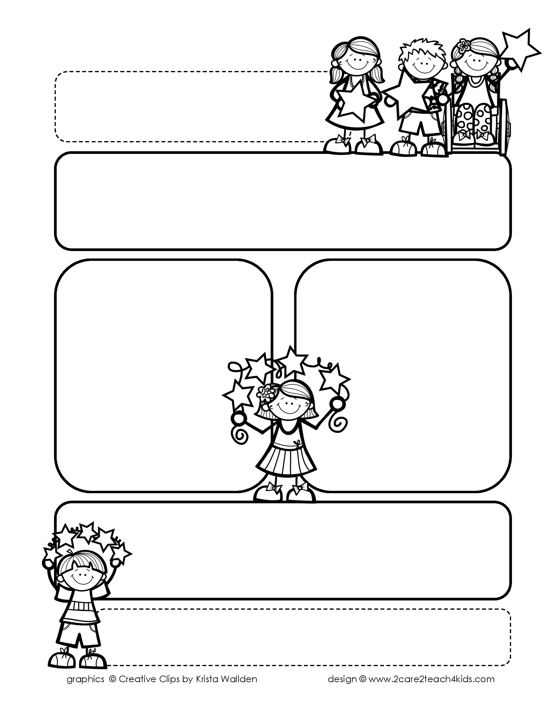

Peek of the Week-First Grade

March 7-11, 2022

, 2021

**Reading/Phonics/Writing**

Students will work on identifying the Author’s Purpose in Fairy Tales, Punctuation, Contractions, Prepositions, Comprehension, read and spell words with /ing/.

.

**Math/Science/Social Studies:**

Students will learn about Measurement and Time.

Students will complete Chp 7 on Weather and test on Thursday.

Students will learn about Texas and its symbols.

Word problems

**Religion:**

Students will learn about How We Celebrate the Mass

.

!

**Reminders:**

* **Tuesday, March 8-Chp.7 Math Test.**
* **Remember your child may bring an offering for the collection basket on Mass Day.**
* **Friday, March 11-Early Release and Spring Break Begins!**

.

**Spelling Words**

* Pre-Test will be given on Monday to determine if your list will be A or B.
* Study list (A or B) and the “Both” words on the spelling

word card. Please keep the Spelling Ring in the pouch that is in Daily folder. A new card will come home every Monday. Also, study the spelling of the sight words on the back of the card.