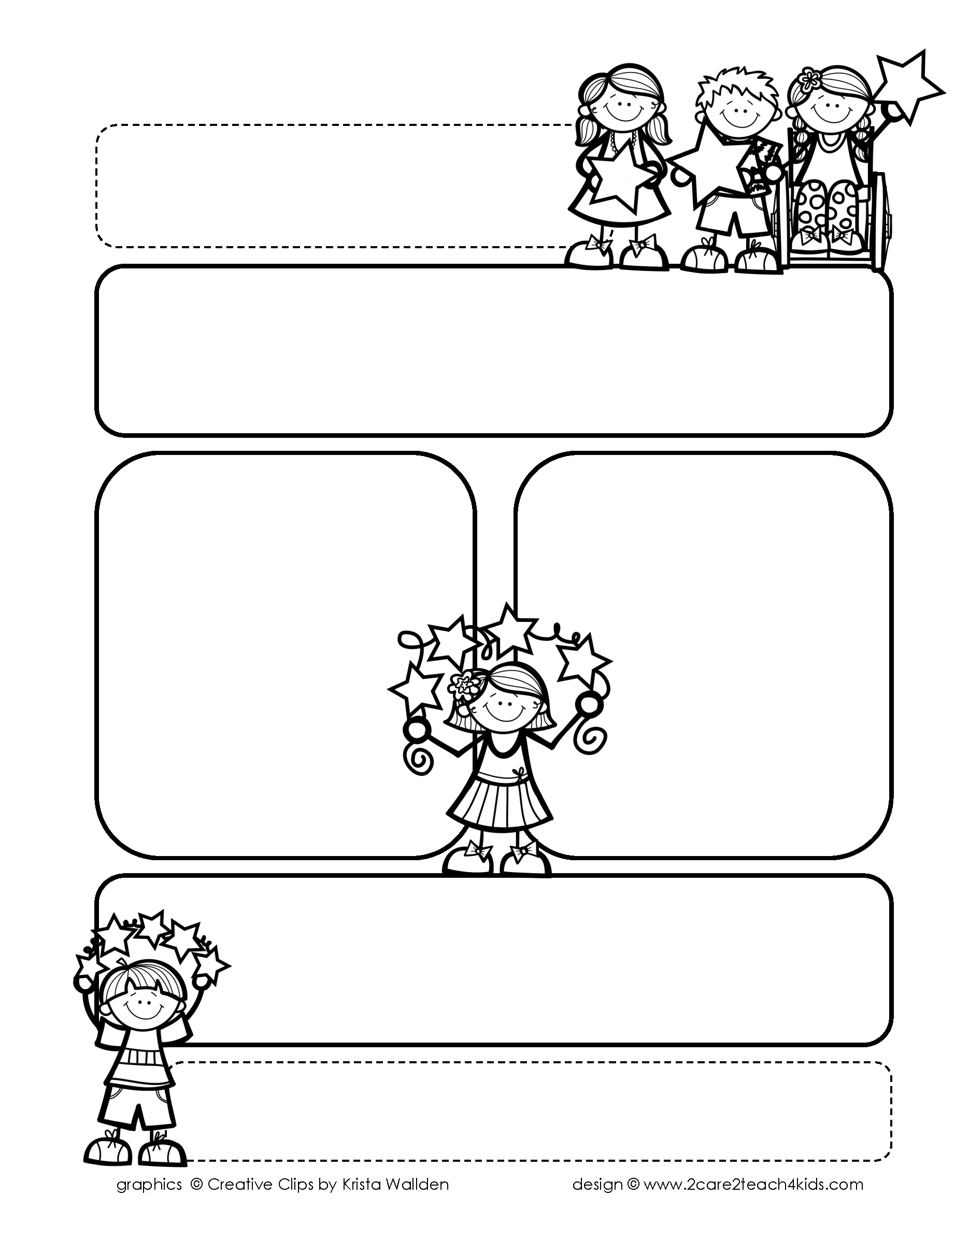

Peek of the Week-First Grade

May 2-6, 2022

, 2021

**Reading/Phonics/Writing**

Students will work on identifying the Author’s Purpose in “Dot & Jabber & the Great Acorn Mystery”-Reading Street, Making Predictions, Inflectional Endings, Subject/Verb Agreement, Writing Poetry and Comprehension.

.

**Math/Science/Social Studies:**

Students will learn about 2D shapes & Equal Shares.

Students will learn about Motion & Energy.

Students will continue to learn about Traditions We Share.

Word problems

**Religion:**

Students will learn about the Blessed Virgin Mary.

.

!

**Reminders:**

* **5/2 NWEA Reading Benchmark**
* **5/3 NWEA Math Benchmark**
* **5/3 Science Test on Insects**
* **Mom’s Tea 5/4 @ 1:45;**

**Students wear Sunday’s best!**

* **5/6 May Crowning of Mary:**

**Your child may bring a flower**

**to have laid by her statue.**

.

**Spelling Words:**

1. **ladybug**
2. **sunflower**
3. **railroad**
4. **football**
5. **moonlight**
6. **grasshopper**
7. **inside**
8. **afternoon**
9. **popcorn**

**10.airplane**