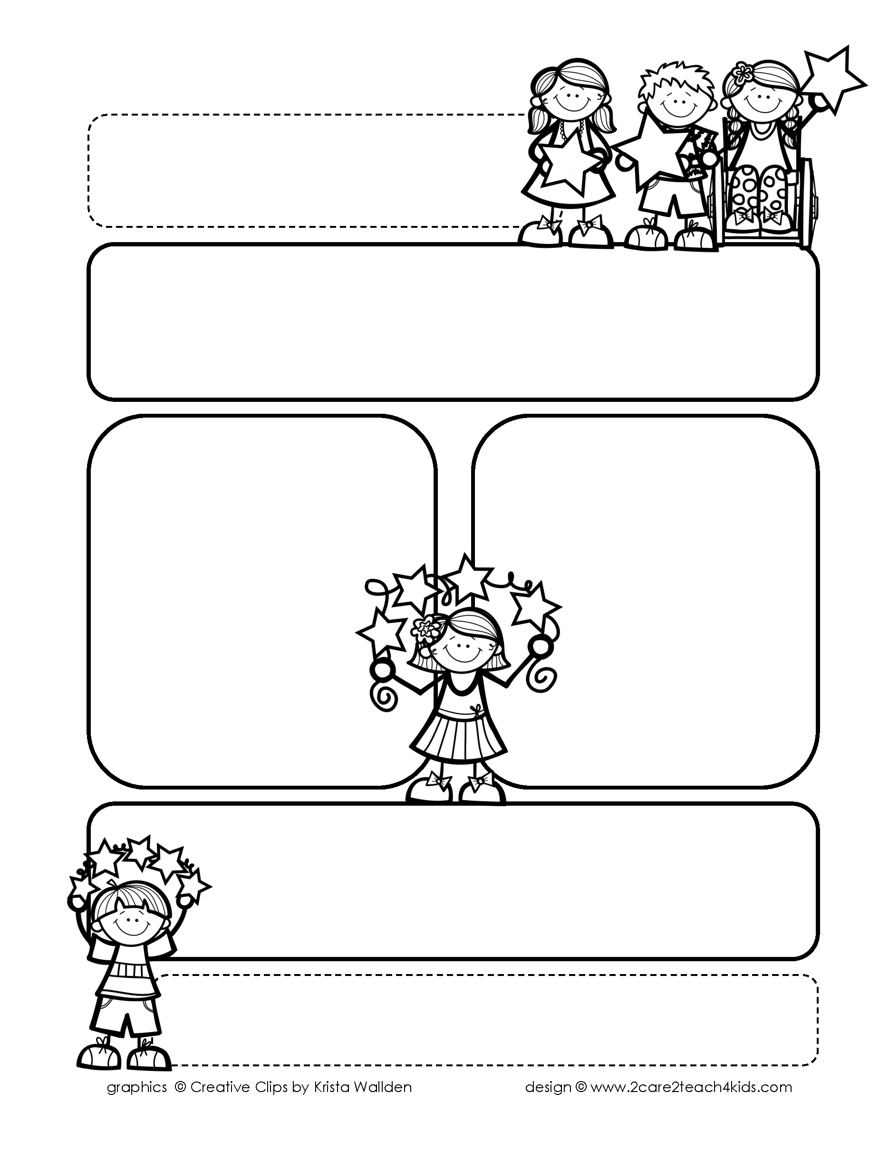

Peek of the Week-First Grade

November 1-5, 2021

**Reading/Phonics/Writing**

Students will work on identifying the Beginning, Middle, End of a story, Author’s Purpose, phonograms “ai/ay,” distinguish between nouns, verbs, adjectives & read and spell words with /a silent e and i silent e/.

.

**Math/Science/Social Studies:**

Students will learn strategies to add 3 numbers together.

Students will continue to learn about Families Long Ago and Today.

Students will learn about Animals and Their Homes .

Word problems

**Religion:**

Students will learn Jesus Died and Rose to New Life

!

**Reminders:**

* Your child may begin bringing books to test on AR.
* November 4th Christmas Pictures.
* Homework is due Friday!

**Spelling Words**

* Pre-Test will be given on Monday to determine if your list will be A or B.
* Study list (A or B) and the “Both” words on the spelling

word card. Please keep the Spelling Ring in the pouch that is in Daily folder. A new card will come home every Monday. Also, study the spelling of the sight words on the back of the card.