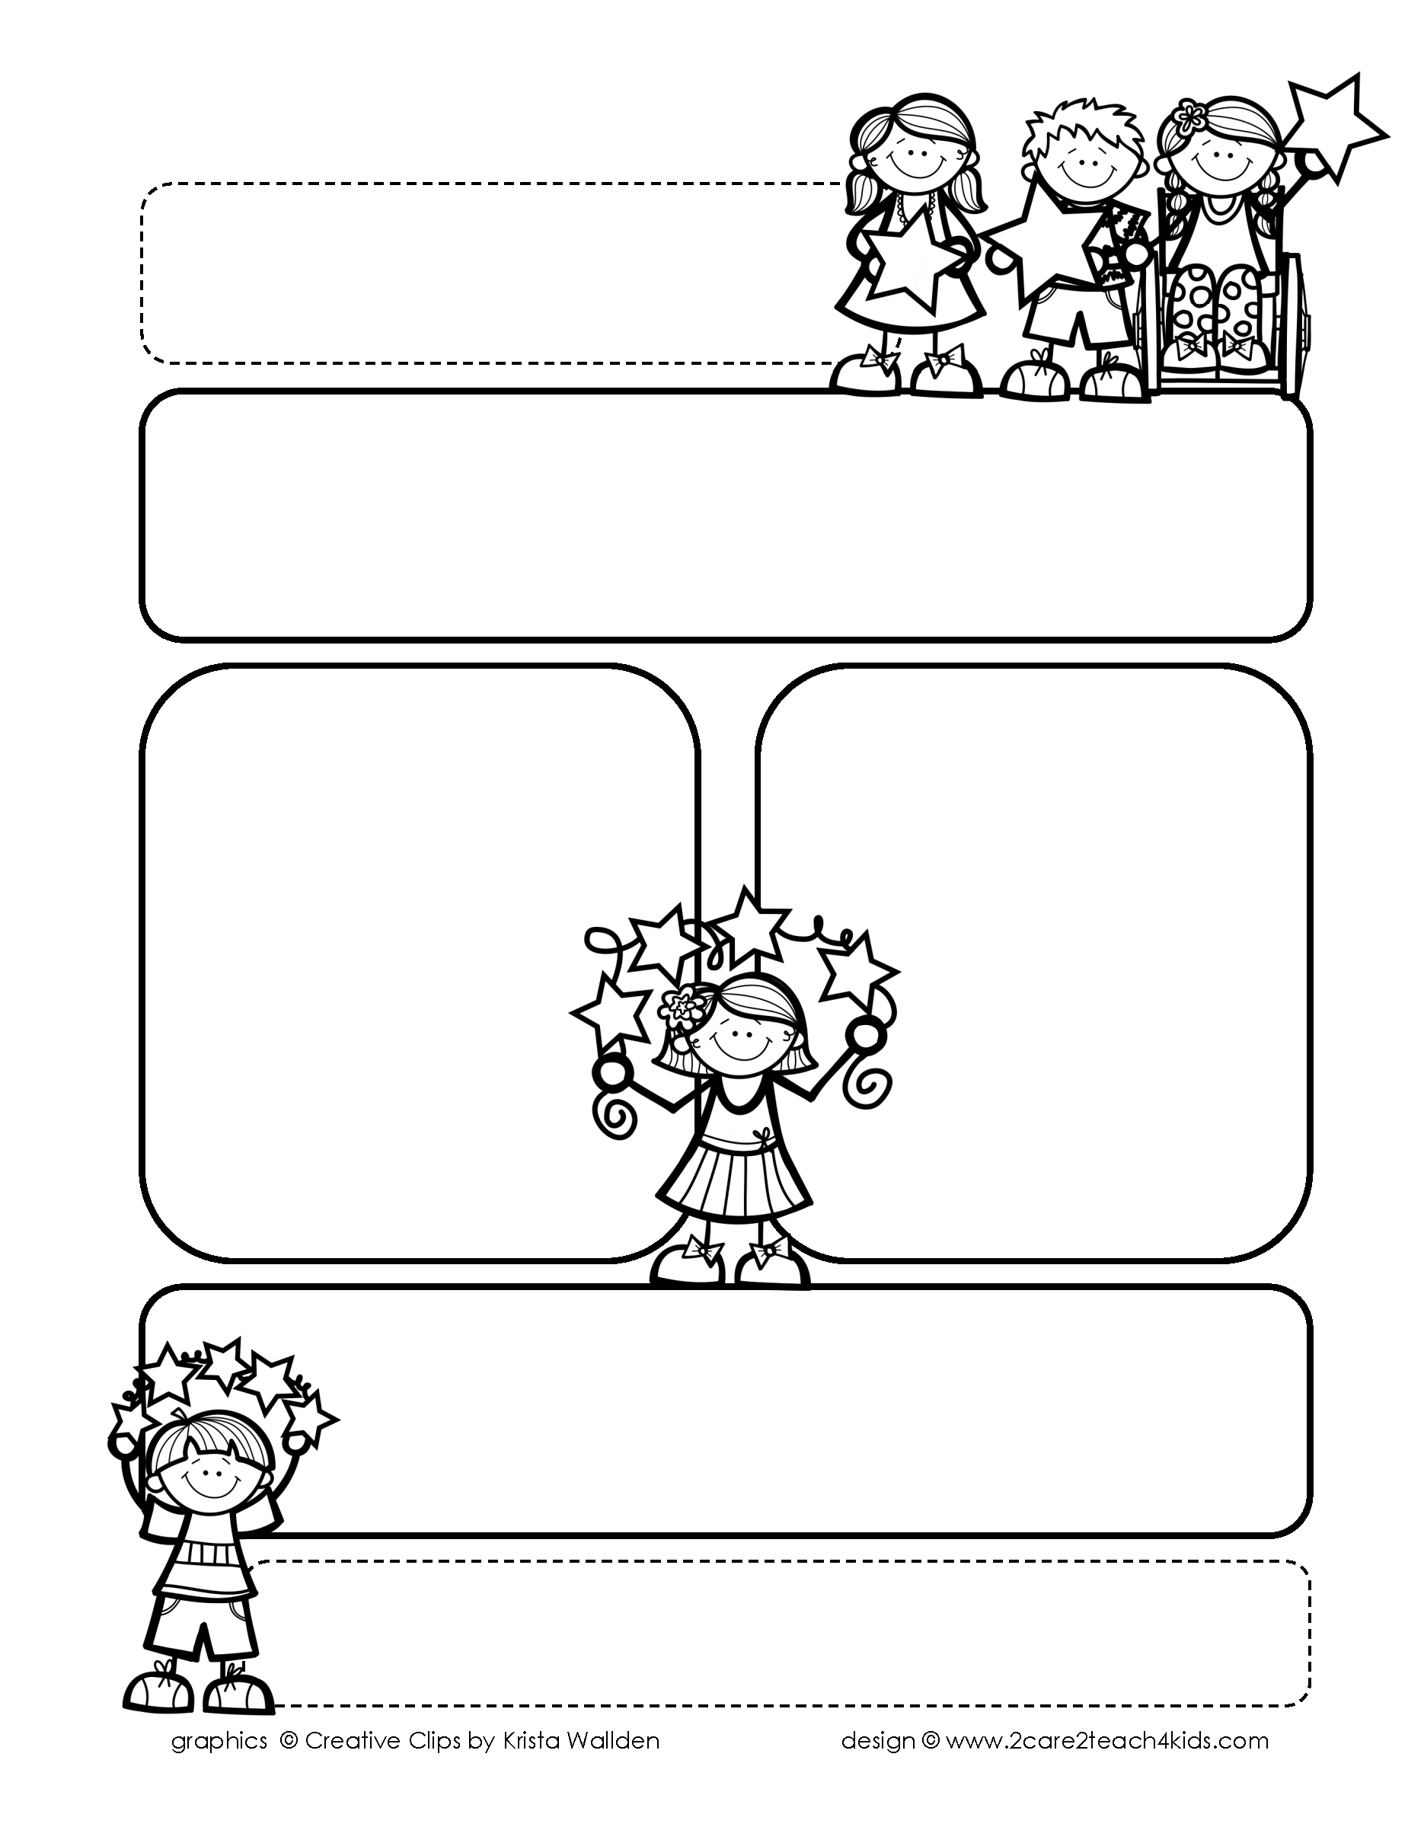

Peek of the Week-First Grade

Nov. 29-Dec. 3, 2021

**Reading/Phonics/Writing**

Students will work on identifying the Main Idea, Beginning, Middle, End of a story, Author’s Purpose, phonogram “or/ar,” contractions & read and spell words with

soft /g/ and /c/.

.

**Math/Science/Social Studies:**

Students will begin Place Value.

Students will continue to learn about Families Long Ago and Today.

Students will learn How Animals Eat Food.

Word problems

**Religion:**

Students will learn The Church Serves.

!

**Reminders:**

* Your child may begin bringing books to test on AR.
* Shoe Boxes are DUE Nov. 29th.
* Nov. 29th -Battle of the Bills!
* Nov. 30th-Giving Tuesday!
* Wednesday, Dec.1st -Math Test
* Homework is due **Friday**! (that includes Spelling Homework)

**Spelling Words**

* Pre-Test will be given on Monday to determine if your list will be A or B.
* Study list (A or B) and the “Both” words on the spelling

word card. Please keep the Spelling Ring in the pouch that is in Daily folder. A new card will come home every Monday. Also, study the spelling of the sight words on the back of the card.