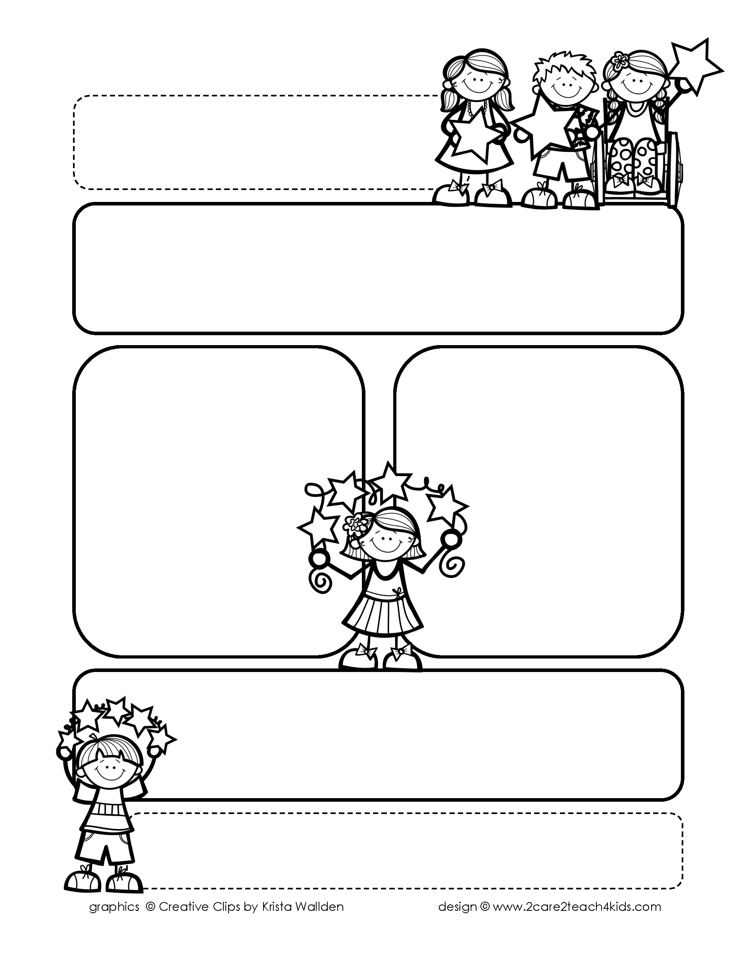

Peek of the Week-First Grade

October 11-15, 2021

**Reading/Phonics/Writing**

Students will understand main idea and details, procedural writing, continue using pronouns, identify adjectives & read and spell words with /l/ blends.

.

**Math/Science/Social Studies:**

Students will continue Subtraction using pictures & counters.

Students will learn that Plants Live in Many Places.

Students will learn about Why We Make Choices.

Word problems

**Religion:**

Students will learn about the Year of the Church!

**Reminders:**

* No School on Oct.11th for

Teacher Inservice!

* Reading & Science Test on Thursday!
* Spelling & Math Test is on Friday!
* Your child should be choosing

Spelling activities for **Homework**

off the Spelling Menu in folder.

* Homework is due on Friday!
* Picture Day is on Oct. 14th.

**Spelling Words**

* Pre-Test will be given on Monday to determine if your list will be A or B.
* Study list (A or B) and the “Both” words on the spelling

word card. Please keep the Spelling Ring in the pouch that is in Daily folder. A new card will come home every Monday. Also, study the spelling of the sight words on the back of the card.