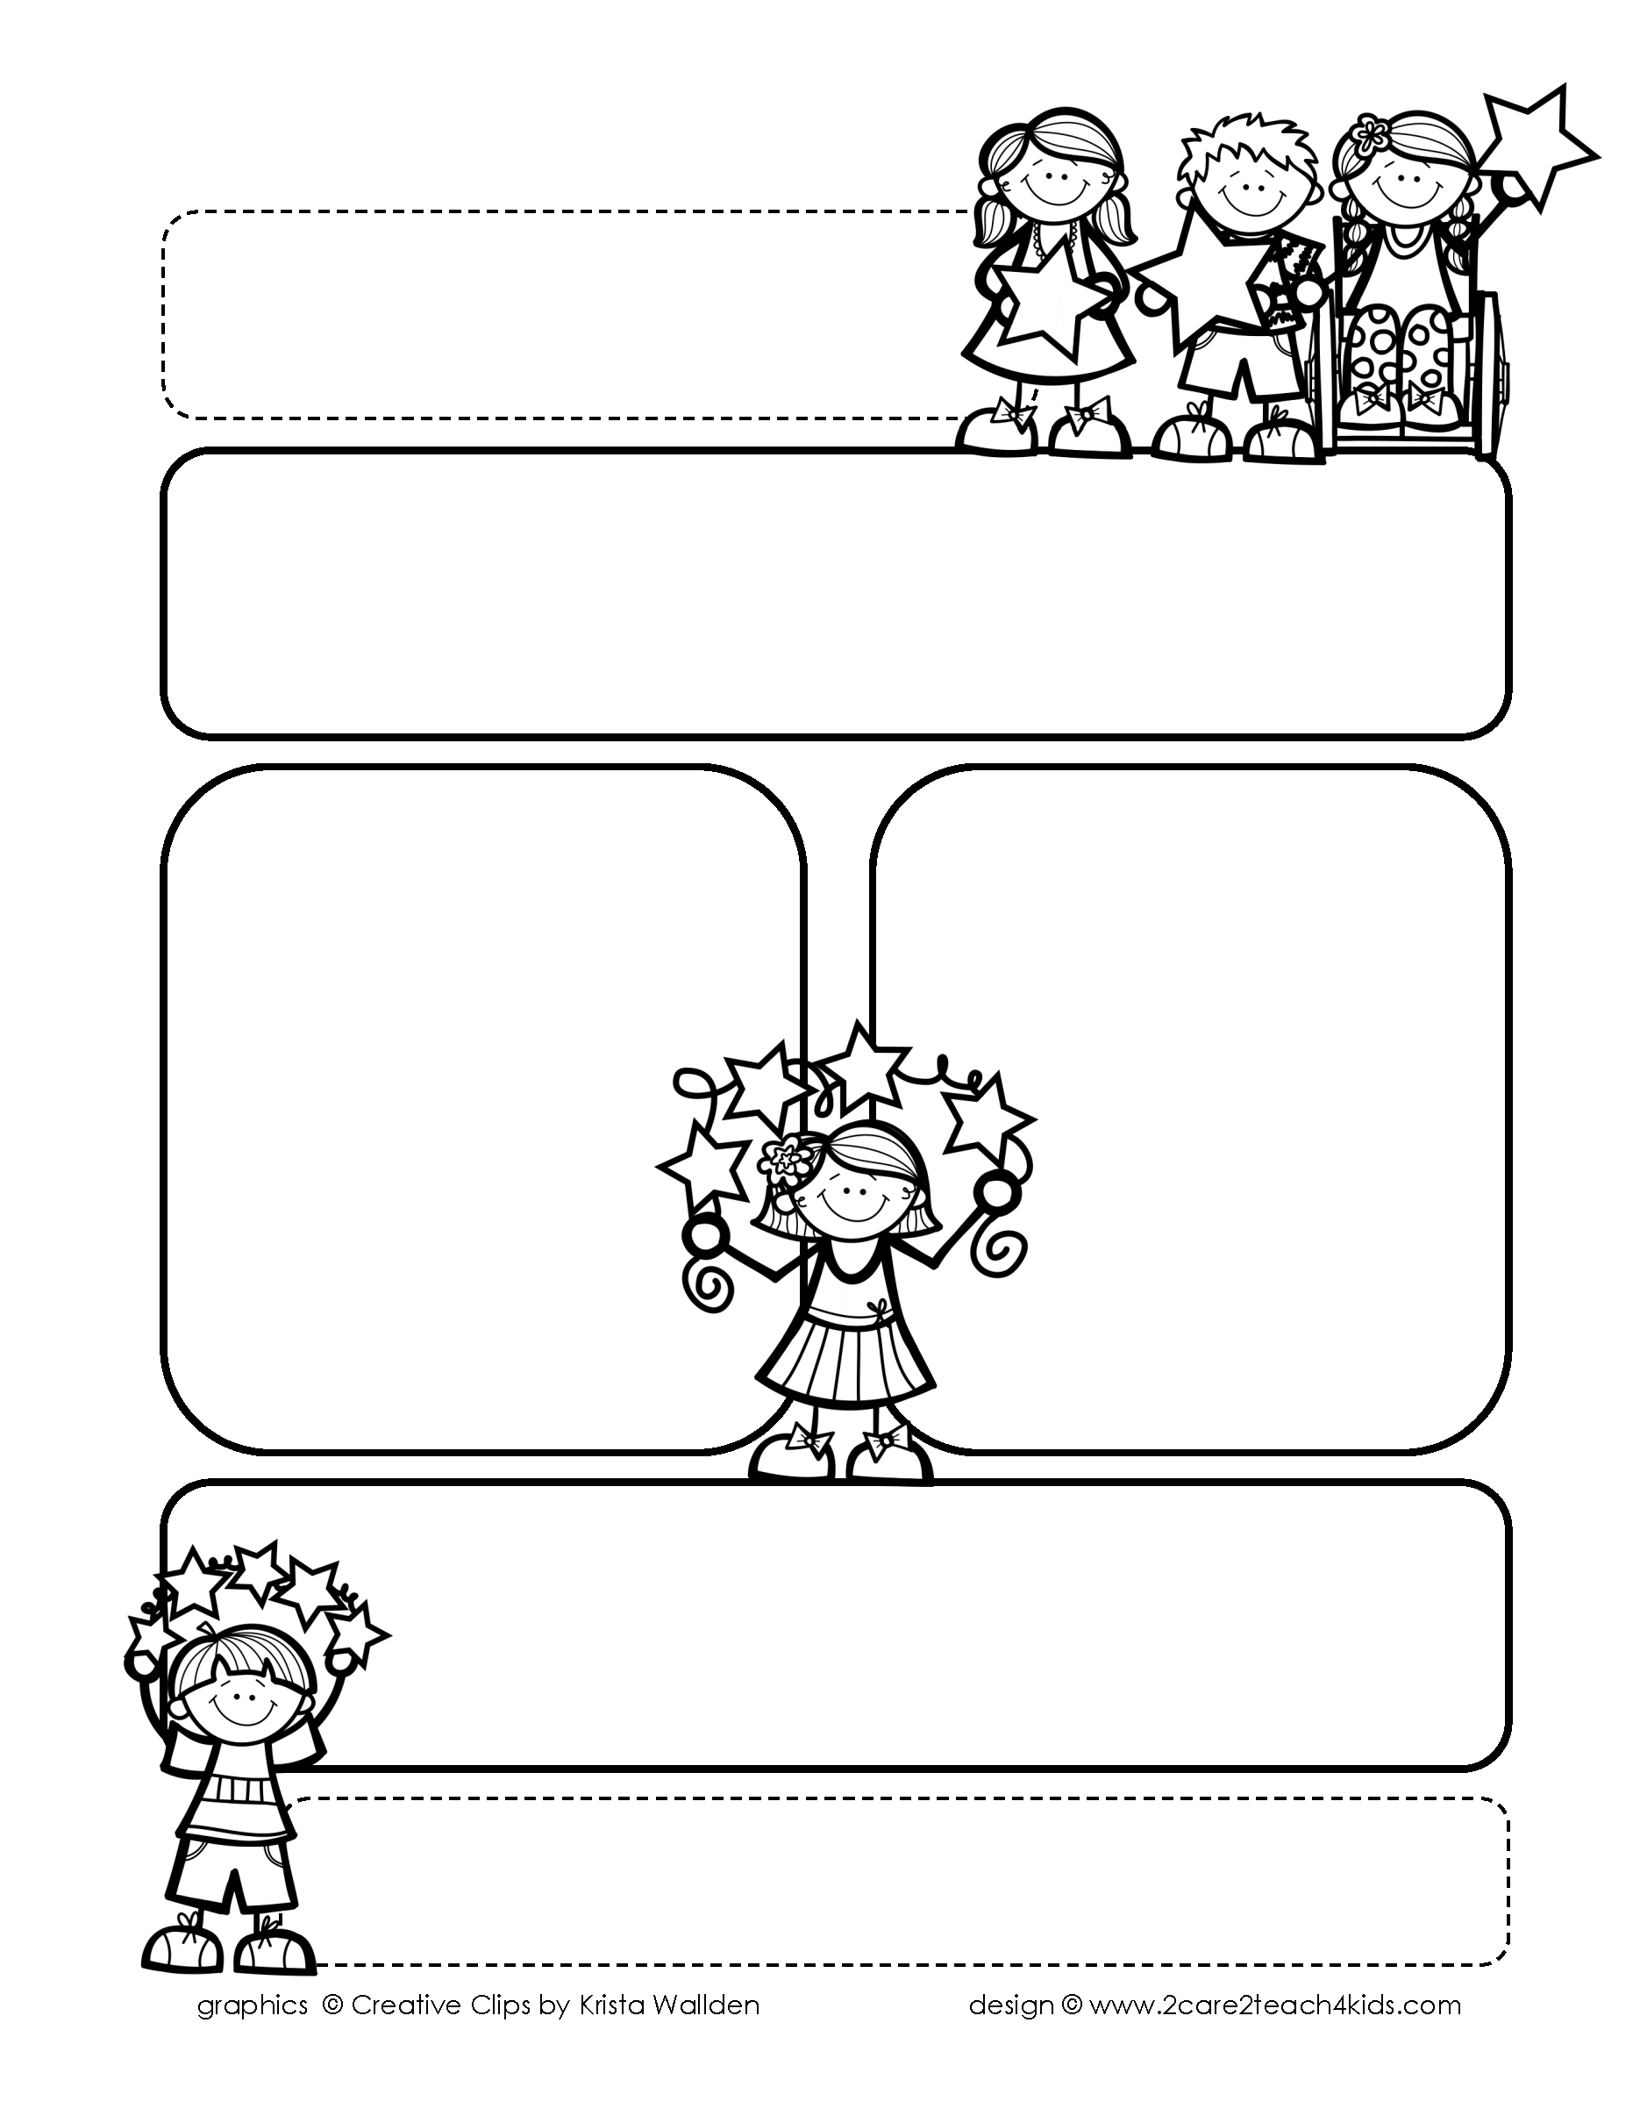

Peek of the Week-First Grade

October 25-29, 2021

**Reading/Phonics/Writing**

Students will enjoy a week of Pumpkin/Scarecrow stories, story elements, understand main idea and details, phonogram “oo,” use adjectives & read and spell words with /ff, ll, ss, zz/.

.

**Math/Science/Social Studies:**

Students will learn Addition Strategies to 20.

Students will continue to learn more about Pumpkins.

Students will learn about Money and Jobs.

Word problems

**Religion:**

Students will learn We Are Followers of Jesus

!

**Reminders:**

* It’s Red Ribbon Week! Refer to flyer.
* **Spelling Homework has changed.**

Please refer to the Homework sheet.

* Oct. 27th Red Ribbon Pep Rally
* Oct. 28th-Social Studies Test
* Oct. 29th-Storybook Day-Dress

as a Scarecrow

* Homework is due Friday!

**Spelling Words**

* Pre-Test will be given on Monday to determine if your list will be A or B.
* Study list (A or B) and the “Both” words on the spelling

word card. Please keep the Spelling Ring in the pouch that is in Daily folder. A new card will come home every Monday. Also, study the spelling of the sight words on the back of the card.